LANKA RAIN WATER HARVESTING FORUM

Rain Water Harvesting Systems at

Finlays Tea (Pvt) Ltd Factory

-Haldamulla-

September 2023

INTRODUCTION
From the tea estates situated amid the misty mountains of Newaraeliya and the jungle valleys of Ratnapura, Finlays Pvt Ltd is a renowned processor and supplier of Nutritive Tea in Sri Lanka. The Tea factory is situated in Haldamulla, Badulla. They approached Lanka Rain Water Harvesting Forum to obtain Rain Water Harvesting Systems in order to address the problem of insufficient potable water for gardening, toilet flushing, and other factory-related uses. Dr. Tanuja Ariyananda, the CEO of LRWHF, suggested the RWHS system design.
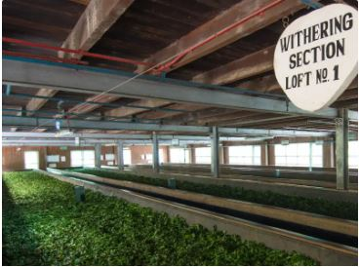
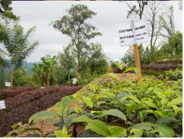

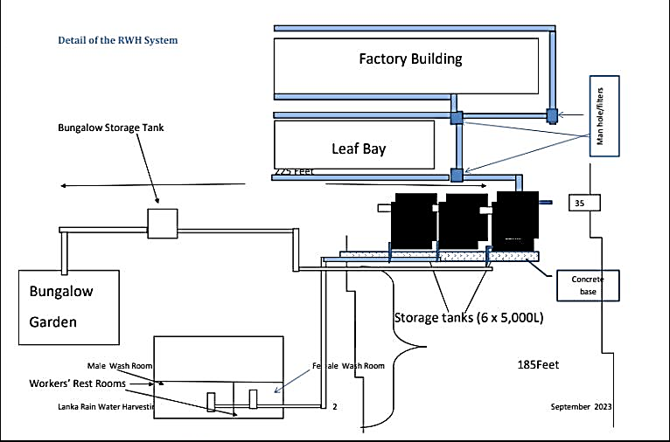
DETAIL OF THE RAIN WATER HARVESTING SYSTEM DESIGN

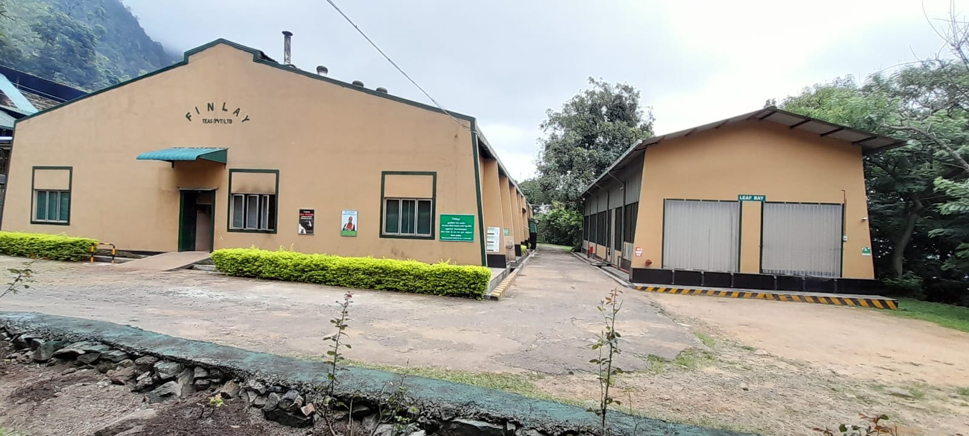
RAINWATER CATCHMENT ROOFS

ROOF AREA
ROOF TYPE | ROOF AREA (m ² )
Factory Roof | 1386
Leaf Bay | 313
TOTAL | 1699

CALCULATION OF WATER CONSUMPTION PER MONTH

The total water consumption for toilet flushing and gardening is as given below,

Day Shift – 4L X (2Buckets) = 8L x 28 workers | 224 L
Night Shift - 4L x (2 Buckets) x 2 =16L X 11 workers | 176 L
Total | 400 L
Gardening per day | 900 L
Grand total per day | 1,300 L
Water usage per month | 39,000 L

CALCULATION OF RAINWATER HARVESTING POTENTIAL

Months | Monthly  Rainfall  (mm) | Monthly potential rain runoff (liters) from the  Factory Roof | Monthly potential rain runoff (liters) from the Leaf Bay Roof | Total potential volume of water ( M³) | Monthly  usage ( M³)
JAN | 64.00 | 70,861 | 16,026 | 86 | 39
FEB | 45.00 | 49,824 | 11,268 | 61 | 39
MAR | 53.00 | 58,682 | 13,271 | 72 | 39
APR | 124.00 | 137,293 | 31,050 | 168 | 39
MAY | 88.00 | 97,434 | 22,035 | 119 | 39
JUN | 59.00 | 65,325 | 14,774 | 80 | 39
JUL | 103.00 | 114,042 | 25,791 | 140 | 39
AUG | 93.00 | 102,970 | 23,287 | 126 | 39
SEP | 123.00 | 136,186 | 30,799 | 167 | 39
OCT | 234.00 | 259,085 | 58,594 | 318 | 39
NOV | 272.00 | 301,158 | 68,109 | 369 | 39
DEC | 145.00 | 160,544 | 36,308 | 197 | 39
Annual Total | 1,403.00 | 1,553,401.60 | 351,311.20 | 1,905 | 468.00

RAIN WATER RUNOFF POTENTIAL
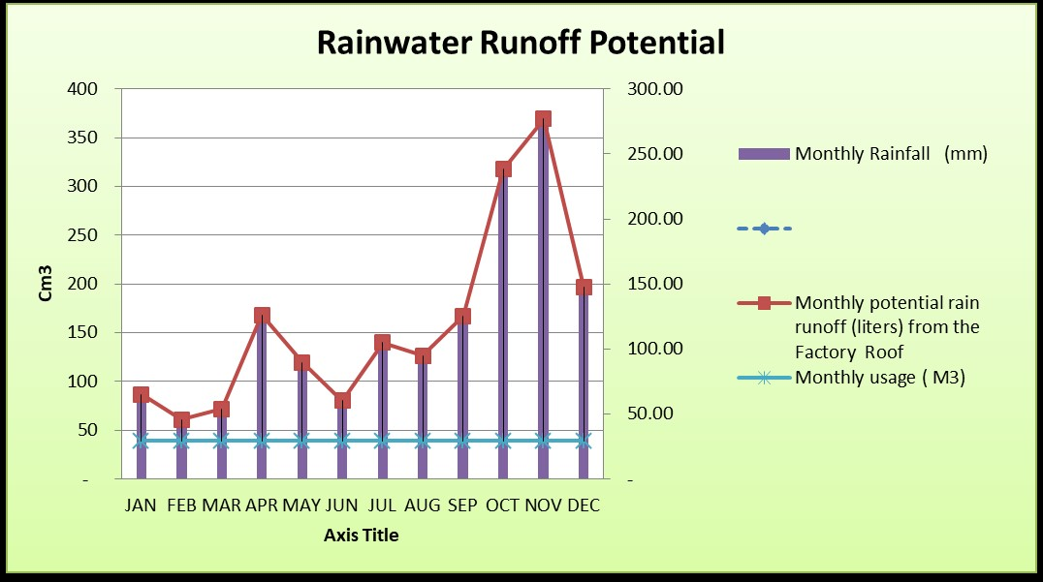

RAINWATER HARVESTING TANK CAPACITY

TANK CAPACITY | NO OF TANKS | TOTAL STORAGE CAPACITY
5,000 L | 6 | 30,000 L

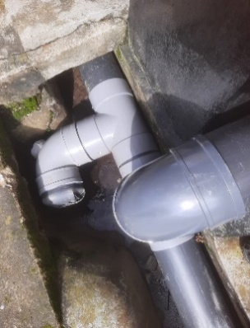
RAINWATER HARVESTING SYSTEM IMPLEMENTED
