Rainwater Harvesting Potential for S-Lon Factory at

Pannala
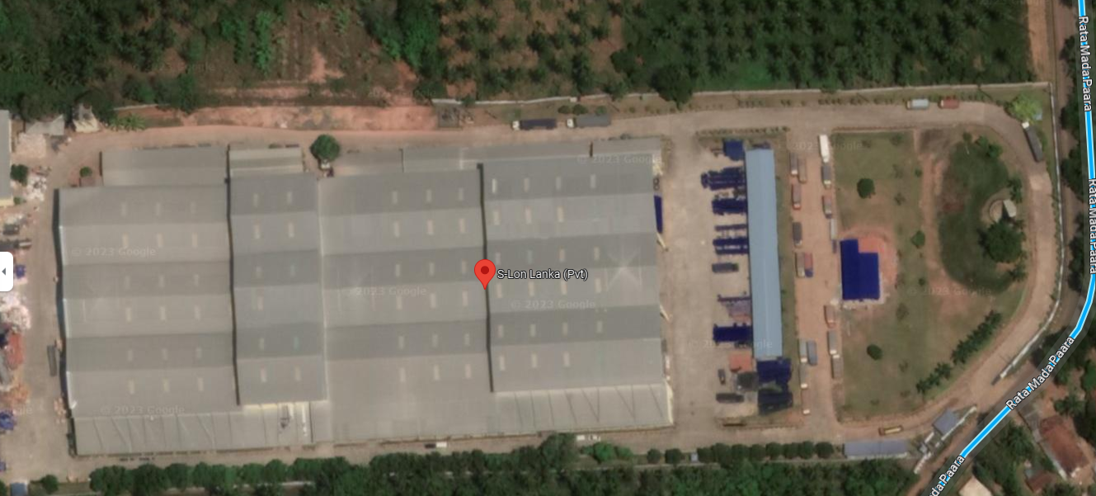

6th July 2008
Context

The objective of the visit was to assess the potential for Rainwater Harvesting, of the factory building, in its final stage of construction.
The contiguous workshop building (700x300 Sq.ft) has 3 distinct roofs with two Valley gutters and 2 end gutters parallel to the longer side of the building , and draining approximately in equal proportions in opposite directions.
An underground sump of 25000 l (25 Cubic metre) had already been constructed , to be used as cooling water in the production process. The estimated cooling water requirement per day was stated to be 5000 l
Considering the rainfall pattern of the area and the figures for over 30 years, the firm yield of a roof of 200 Sq. m with a 50000 litre storage would be about 700 litre per day. As the roof is over 20,000 Sq. M, a 5000 Cubic metre storage would ensure a minimum of 70 Cubic Metres firm daily yield. This figure would be well above the daily factory requirements for all purposes.
As the constraint is the size of the storage rather than the quantity of water which can be collected, the following are proposed sequentially (not necessarily in the given order) ,to be implemented with available budgets and directions laid by corporate responsibility.
- Check with structural Engineer whether Rainwater tanks could be placed at an intermediate level under the present elevated water tank structure. If possible, some of the downpipes to be connected to a common feeder pipe (than discharging to the drain) and be pressure fed to this tank, which should be as large as possible. The water could be gravitated down to the Lunch/Restroom/Toilets etc.
- Construct a ferrocement (Low cost) of 60-80 cub m capacity (A 6 m diameter, 2.2 m high tank, would contain about 60 Cubic meter) in the front or back of the factory for Rainwater storage. Modifications to some downpipes as above would be required. Any additional water could be gravity fed to outside the factory as part of the corporate responsibility.
- Drains coming from the front portion of the roof can be directed to an open pond either at upper level or middle level car park and water collected can be used for gardening and would also have a landscape value.
- Addition of additional tanks as and when space and funds allow. For example, tanks (steel, Ferro cement or plastic) placed at the back of the factory can be used for irrigation purposes of the land below.
- The toilets be plumbed for rainwater and installed with modern No Flush Urinals, Aerator Faucets, bidet type showers to reduce water consumption.
As the water use of the factory seems to be minimal, with adequate storage built in stages, the factory has the potential to have a high Green Rating by managing solely on Rainwater supply.
The Policy on Rainwater Harvesting
(http://www.lankarainwater.org/rwhsl/policy.htm) approved by the Cabinet in June 2005, is an endorsement for stepping boldly in the direction of harvesting, storing and utilizing Rainwater to its fullest potential.

Visited by. Mr Duleep Gunawardena (Engineer), Board Director of LRWHF
Ms. Tanuja Ariyananda, Director, LRWHF

