Rain Water Harvesting Potential at Galle Face Hotel, Colombo

February 2018

Introduction:
Following a request for a feasibility study to assess the potential of rain water harvesting from Galle Face hotel Colombo, a visit was made by Dr Tanuja Ariyananda, CEO, LRWHF on the 15/12/2017 to the premises.
During the visit and later following information were obtained
- Roof Area of the hotel: estimated: 7871 m² (84,7265 ft²)
- Storage available: South Garden 42 m³ + 61m³ + 124m³ = 227 m³
- Front of veranda, Restaurant garden= 150 m³
- Monthly average water consumption: 7,395,667 liters
Water needed for laundry, gardening, dish washing, toilet flushing
- Number of rooms: 156
- Drinking water for hotel guest and workers are provided by bottle water

Rain Water Harvesting Potential Calculation

Rain fall or Colombo

Chart 1
Runoff Potential as Per Annual Rainfall
Annual rainfall  (mm) | Total RWH potential  (Liters) from All roofs
2,404 | 16,081,558
Table 1

Storage Potential as per Catchment Variation
Chart 2

Runoff Potential (Monthly) from Roofs (table 1)

Months | Monthly Rainfall (mm) | Monthly potential rainfall (liters)All Roof top | Monthly potential rainfall (liters)Roof Area A | Monthly potential rainfall (liters) Roof Area B | Average Monthly demand ( liters)
Jan | 62.00 | 414,749 | 52,173 | 44,953 | 7,395,667
Feb | 69.00 | 461,576 | 58,064 | 50,028 | 7,395,667
Mar | 130.00 | 869,635 | 109,395 | 94,257 | 7,395,667
Apr | 253.00 | 1,692,444 | 212,900 | 183,438 | 7,395,667
May | 382.00 | 2,555,389 | 321,453 | 276,969 | 7,395,667
Jun | 186.00 | 1,244,247 | 156,519 | 134,859 | 7,395,667
Jul | 125.00 | 836,188 | 105,188 | 90,631 | 7,395,667
Aug | 114.00 | 762,603 | 95,931 | 82,656 | 7,395,667
Sep | 236.00 | 1,578,722 | 198,594 | 171,112 | 7,395,667
Oct | 369.00 | 2,468,426 | 310,514 | 267,543 | 7,395,667
Nov | 310.00 | 2,073,745 | 260,865 | 224,766 | 7,395,667
Dec | 168.00 | 1,123,836 | 141,372 | 121,808 | 7,395,667
 | 2,404.00 | 16,081,558 | 2,022,966 | 1,743,020 | 88,748,000
Table 2

Chart 3 potential RW collection from roof A to Storage Tank A

Chart 4 Potential RW collection from Roof B to Storage Tank B

Description of Proposed Roof Water Collection Plan

Feasibility Calculation:
- Total roof area 7871 m²
- Roof Area A= 990 m2 (figure 1)
- Roof Area B = 853 m 2 (figure 1)
- Average Monthly demand: 7395.7 m³
- Average Annual demand = 7395.7 m³ x 12 = 88,748 m³
- Annual Rain Water harvesting Potential from all Roofs = 16, 082 m³
- Annual roof water potential from roof A only = 2023 m³
- Annual roof water potential from roof B only = 1743 m³

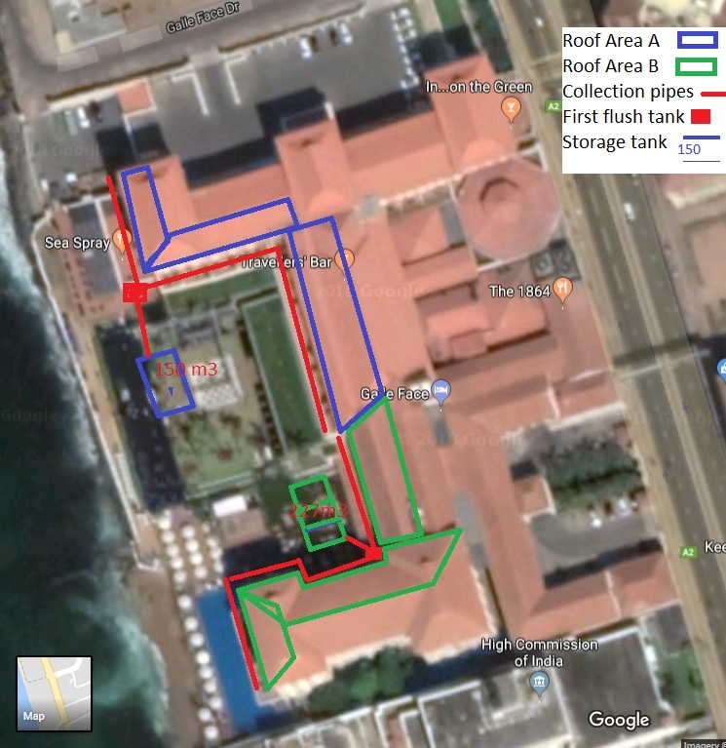
Figure 1
Since the water demand is high, it is not possible to collected total water demand of the hotel by collecting roof rain water. Only an estimated average 8% of the demand can be met by collecting rain water from all the roofs, with adequate storage.
However, with existing storage of 227 m³ and 150 m³ and collection from roof area of A and B (figure 1) around 4% of the water demand can be met.
Roof water from roof areas A and B can be collected from gutters through down pipes and delivered by a PVC/Concrete pipe of larger diameter (6-8 inches) which can be places inside the existing drains or underground pipes, as in the figure 1. PVC /Concrete pipe should be connected together and deliver into existing storage tanks placed in the location as in the figure 1.
The first flush tank, collecting any dust and possibly salt deposits in the roof due to the hotels proximity to the sea, washed off with the first rains, will prevent any such contaminants deposited in the roofs entering into the storage tanks, which is discarded. This can be done by directing the first 2mm of rain (1.7 - 2 m³ volume) from each roof into at tank before the rain water goes into storage tank (Figure 2). There are also commercially available filters which will automatically prevent these contaminant entering the storage tanks (see attached annex: vortex filter)
Economic feasibility of this option should be calculated taking into account present cost of water, future increases taking into account that after the system is installed there will only be maintenance cost to the system, which is very minimal.
Estimated Cost
- Storage: Existing underground tank: no cost
- Delivery: length of 6-8 inch PVC/concrete around the buildings of roof areas A and B and laying of underground pipes from roof area A and B to storage tank location (since the distances are not know, it is not estimated)
- First flush tank: 2 m³ capacity Rs, 30,000 or
- Vortex filter: please contact http://www.rainconcepts.com/index_files/systems.htm

Recommendation
- It is recommended to use the existing storage capacity at the initial stage with plan for future installation of additional storage capacity with use of additional roof areas, if and when needed
- All water storage facilities should be kept closed to prevent mosquito breeding and algae forming.
- First flush tank can be placed underground. Vortex filter can be added if quality of the water collected is not meeting the standard required.
- Quality of the collected water is to be tested, for chemical and bacteriological standard if it is being used for human consumption or comes in contacted with humans.

Figure 2; Design of First flush tank and vortex filter
Outlet to storage tank
washout
Inlet -from delivery pipe 6”
2000 liter tank of Concrete/brick/PE

Annex 1: Vortex Filter