Rainwater Harvesting Potential at Coca-Cola Factory Premises at Biyagama

July 2018
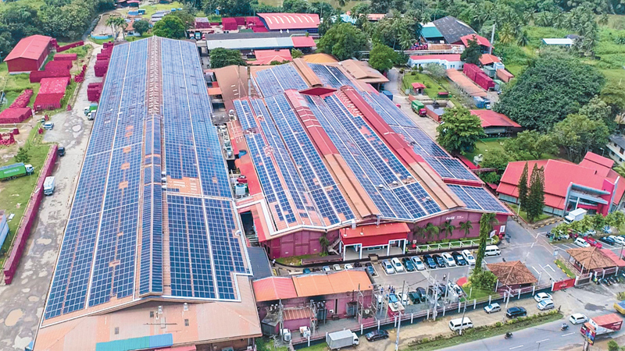

Introduction
Further to previous 2 reports (21st December 2017 and 4th June 2018), after discussion with the team at Biyagama Coca-Cola on the 17th July 2018 a new calculation was made to assess the feasibility of collecting the run off rain water from 3 main roof areas.
16,000 m² (largest)
Roof Area of the 3 main buildings

120500 litres per day or 3,617 m3 per month
water demand for non-beverage production

Rain Water Harvesting Potential Calculation

Rain fall for Biyagama (Gampaha)

Chart 1 Source: https://en.climate-data.org/location/1012453/

Runoff Potential as Per Annual Rainfall
Annual rainfall  (mm) | Total RWH potential (m3) from 3 major Roofs
2,398 | 32,613 m3
Table 1

Run off potential from Catchments and Demand Variation

Chart 2

Runoff Potential (Monthly) from Roofs (table 1)
Months | Monthly Rainfall (mm) | Monthly potential rainfall from 3 main roof ( m³) | Average Monthly Water demand for non-beverage production ( m³) | 75%of Water demand for non-beverage production ( m³)
JAN | 62 | 843 | 3,617 | 2,532
FEB | 79 | 1,074 | 3,617 | 2,532
MAR | 146 | 1,986 | 3,617 | 2,532
APR | 255 | 3,468 | 3,617 | 2,532
MAY | 353 | 4,801 | 3,617 | 2,532
JUN | 216 | 2,938 | 3,617 | 2,532
JUL | 134 | 1,822 | 3,617 | 2,532
AUG | 123 | 1,673 | 3,617 | 2,532
SEP | 202 | 2,747 | 3,617 | 2,532
OCT | 365 | 4,964 | 3,617 | 2,532
NOV | 311 | 4,230 | 3,617 | 2,532
DEC | 152 | 2,067 | 3,617 | 2,532
Total | 2,398.00 | 32,613 | 43,404 | 30,383
Table 3

Feasibility Calculation
- Annual run off from all 3 main roofs = 32,613 m³
- Maximum collection during a month is 4964 m³
- Annual water demand for non-beverage production = 43,404 m³
Since annual run off exceed annual demand for non-beverage production, total demand for non-beverage production cannot be collected from main 3 building. However, 75% of the annual demand for non-beverage production of 30,383 m³ can be met through collecting the run off from the 3 main buildings.

The calculation for Storage capacity
Rainwater Tank Performance Calculation
Biyagama
Location
16000 m²
Roof area

120500 liters’

nominal demand
Mean daily runoff
90591 liter’s

water management strategy
Constant Demand
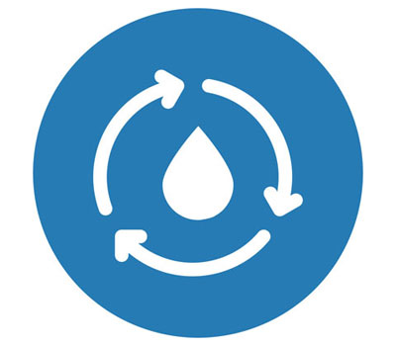

Using the nominal demand and tank size that you specified of 120500 litres per day:
 | Your Tank | Comparisons
Tank Volume (litres) | 800000 | 453000⁴ | 1811800⁴ | 7247300⁴
Reliability¹ | 44% | 27% | 59% | 71%
Satisfaction² | 55% | 44% | 66% | 76%
Efficiency³ | 73% | 59% | 88% | 100%

Using a calculated⁵ nominal daily demand of 90591 litres per day:
 | Your Tank | Comparisons
Tank Volume (litres) | 1000000 | 453000 | 1811800 | 7247300
Reliability | 64% | 42% | 74% | 92%
Satisfaction | 71% | 54% | 78% | 94%
Efficiency | 71% | 54% | 78% | 93%

Notes
- Reliability is the fraction of days the total demand will be met by the system
- Satisfaction is the fraction of the total water demand that can be met by the system
- Efficiency is the fraction of the runoff from the roof captured by the system
- The comparison tank volumes are based on the average daily roof runoff multiplied by days, 20 days and 80 days respectively

Recommendation
- 1000 m³ storage tank will give 75% of the demand (90591 litres per day) 71% of the times
- Delivery pipe can be laid inside the existing drainage system to minimize disruption to the site infrastructure
- Storage tanks can be placed above ground or/and underground. If it is above ground water will have to be pumped up continuously.
- Overflow should be directed to the storm water drains
- First flush system should be installed to reduce any contamination from the roof.
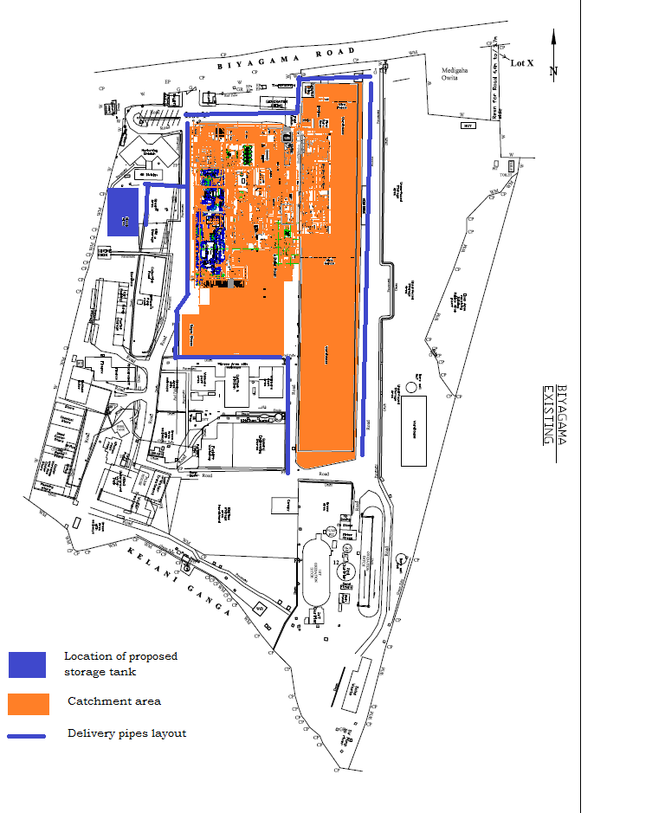
Underground tank
Roof drain direction
Underground drain
First flush tank

