**Feasibility of Constructing a Rain Water Harvesting System for CINEC Maritime Campus, Malabe**

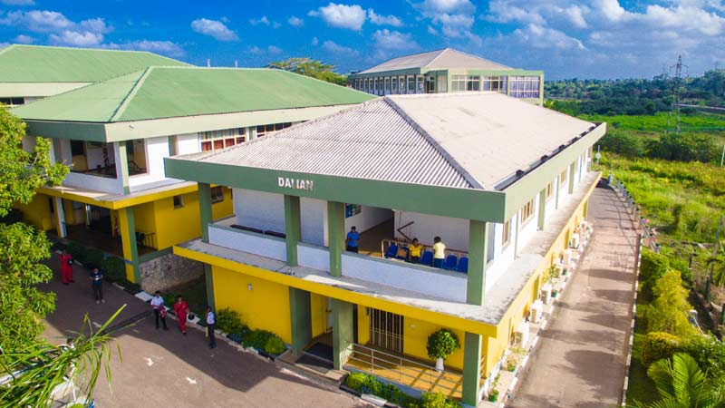



**Description**



The complex has 10 main buildings with large roof areas. The roof areas of these building are given in Table 1. The rain water from each roof is collected into a large gully which runs along the sides of the roof, and disposed into drains around the building through number of downpipes. The buildings are located at different levels with building 1 (workshop) at the highest level and Building 7 (Main building) at the lowest level. There are 3 wells located in the complex, two in the NW and one in the South of the complex. Total number of people occupying the building during the day is 300 and at night in the hostel 50.

The complex gets NWS&DB supply which is used for drinking water and directly connected to the pipes. Well water is pumped into a sump of estimated 500 m3 capacity twice daily for supplying toilets, washing and gardening.



**Estimate requirement of water per day**

300 persons during the day = 300 *l* x 50 =15000 *l*

50 persons night = 75*l* x 50 = 3750 *l*

Total requirement per day = 18750 *l* = 18.75 m3

Total requirement per month = 562.5 m3



**Observation**

Since there is water available in the wells during most time of the year, there is no real water shortage at the site, except during the dry seasons. However, pumping water daily from the wells consume large quality of electricity. There is potential to collect large quality of rainwater from the large roof areas. The total monthly requirement of water can be stored in the sump available.

Table

|  |  |  |  |
| --- | --- | --- | --- |
| **Building No.** | **Roof Area (m2)** | **Average Potential Monthly Rainwater that can be collected (m3)** | **The volume of the First flush to be discarded (m3)** |
| 1 | 1461 | 263 | 1.46 |
| 3 | 272 | 49 | 0.27 |
| 4 | 453 | 81 | 0.45 |
| 5 | 453 | 81 | 0.45 |
| 7 | 865 | 156 | 0.87 |
| 8 | 302 | 54 | 0.30 |
| 9 | 403 | 72 | 0.40 |
| 10 | 403 | 72 | 0.40 |
| **Total** | **4612** | **828** |  |



**Suggestion**

1. Separate the drinking water from water needed for other use such as toilet, washing, gardening at present. Later after testing the quality of rain water collected you can use rain water all purposes.
2. Rain water collection and can be introduced in stages. Some of the options are stated below.
3. Rain water can be used for recharging the wells located within the complex.



**Options**

1. Connect all the down pipes of the workshop roof (Building 1) through a first flush and filter into the sump. The first flush tank should be 1.5 m3 in capacity. This will provide enough water during rainy season, and reduce on pumping water from wells.
2. Collected roof water from the roof of each building into a under ground storage tank located near the building and pump the water to a over head tank on the same building. The potential capacities of each tank is given on the table 1
3. Roof water of building No 3,4,5 can be directed through a filter to the well near by for recharging.
4. Roof water of building No. 7 can be directed through a coarse filter to well near it.
5. Roof water of building no. 8 can be directed through a coarse filter to well near it.
6. Construct a large capacity tank near the entrance connect all the drains to it through a first flush filter and pump up to the sump when necessary.



**Suggested Rain Water Harvesting System for Workshop (Building No.1) at CINEC Maritime Complex.**

Existing sump

First flush and filter

Down Pipes

Figure 1