July 2022
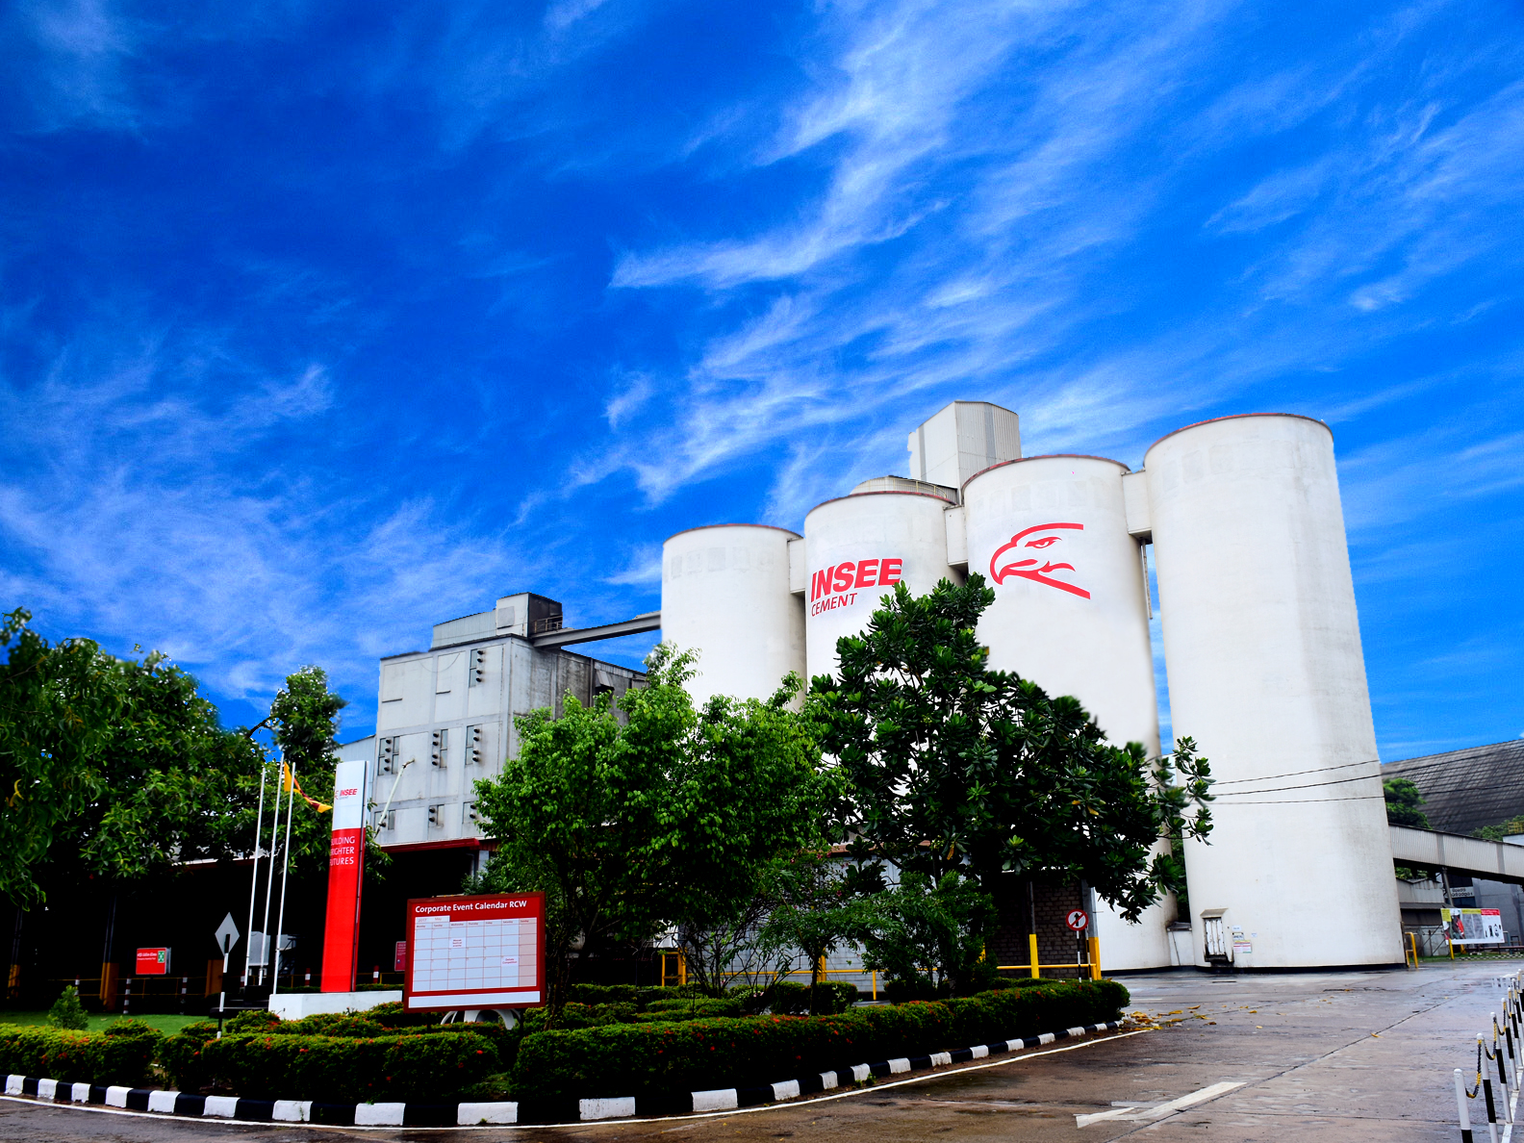
DESIGN OF RAIN WATER HARVESTING SYSTEM FOR SIAM CITY CEMENT
(LANKA) LIMITED,
GALLE.

Introduction:

A visit was made to the Siam City Cement (Lanka) Limited Factory premises on the 8th of July 2022 to study the feasibility of rainwater harvesting for it use. Location: Ruhunu Cement Works, Sri Lanka.

- Roof Area (largest) of Palletizer warehouse = 5850 m²
- Water need per month (average for Customer area and changing rooms) = 2500 m³
- Rain fall band: Galle District

Rainwater Harvesting Potential Calculation
Figure 1 Monthly Mean Rainfall for Galle District (2021-2011)

84

66

92

200
297

177

154

160

261

315

289
159

-
50
100
150
200
250
300
350
JAN
FEB
MAR
APR
MAY
JUN
JUL
AUG
SEP
OCT
NOV
DEC
Rainfall

Run off calculation from Palletizer warehouse for total monthly demand

Table 1
Months | Monthly  Rainfall (mm) | potential rain  runoff (liters) from the Roof | Total potential volume of water (Meter cube) | Monthly usage (  M3)
JAN | 84.12 | 393,689 | 394 | 2,500
FEB | 66.31 | 310,347 | 310 | 2,500
MAR | 91.66 | 428,992 | 429 | 2,500
APR | 200.36 | 937,664 | 938 | 2,500
MAY | 296.55 | 1,387,848 | 1,388 | 2,500
JUN | 177.48 | 830,586 | 831 | 2,500
JUL | 153.83 | 719,931 | 720 | 2,500
AUG | 160.34 | 750,391 | 750 | 2,500
SEP | 261.45 | 1,223,599 | 1,224 | 2,500
OCT | 315.27 | 1,475,487 | 1,475 | 2,500
NOV | 288.53 | 1,350,297 | 1,350 | 2,500
DEC | 159.32 | 745,602 | 746 | 2,500
 | 2,255.22 | 10,554,433.12 | 10,554 | 30,000.00

Since annual demand of 30,000 m³ exceed the annual supply potential of 10,554 m³, total demand for customer area and washing will not be met through rain run off collection from Palletizer ware house (table 1).
However, on average 30% of the monthly demand of 750 m³ can be met through rain water harvesting (table 2) if large storage capacity tank 1500 m³ can be constructed.

Runoff calculation from Palletizer warehouse for monthly 30% of the monthly demand
Table 2
Months | Monthly  Rainfall (mm) | potential rain  runoff (liters) from the Roof | Total potential volume of water (Meter cube) | Monthly usage (  M3) | Monthly usage (  30%) M3
JAN | 84.12 | 393,689 | 394 | 2,500 | 750
FEB | 66.31 | 310,347 | 310 | 2,500 | 750
MAR | 91.66 | 428,992 | 429 | 2,500 | 750
APR | 200.36 | 937,664 | 938 | 2,500 | 750
MAY | 296.55 | 1,387,848 | 1,388 | 2,500 | 750
JUN | 177.48 | 830,586 | 831 | 2,500 | 750
JUL | 153.83 | 719,931 | 720 | 2,500 | 750
AUG | 160.34 | 750,391 | 750 | 2,500 | 750
SEP | 261.45 | 1,223,599 | 1,224 | 2,500 | 750
OCT | 315.27 | 1,475,487 | 1,475 | 2,500 | 750
NOV | 288.53 | 1,350,297 | 1,350 | 2,500 | 750
DEC | 159.32 | 745,602 | 746 | 2,500 | 750
 | 2,255.22 | 10,554,433.12 | 10,554 | 30,000.00 | 9,000.00

Figure 2: Run off Potential and Monthly usage
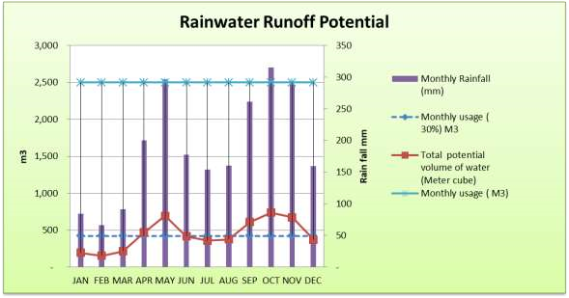

Since 1500 m³ is large capacity storage tank and would be very expensive to construct, it is feasible to look at other options. Table 3 gives summary of service level predicted from different capacity storage tank.

Summary of Service Level expected for Different Months from Different Capacity Tanks

Table 3
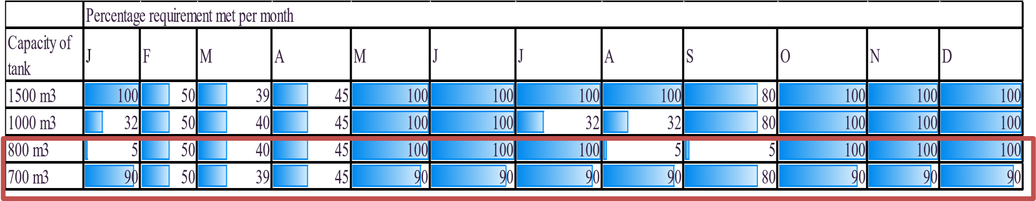

Accordingly, to get the best service level at a reasonable cost storage capacity of 700-800 m³ is recommended.
According to the site layout and water usage requirement 3 option are recommended (Figure 3).
All 3option can be implemented together or at different stages.

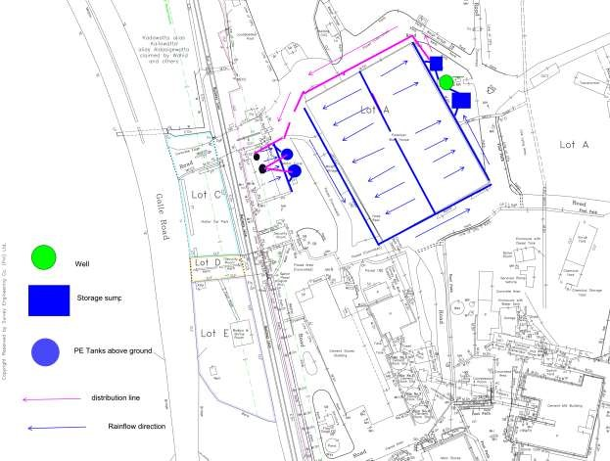
Figure 3: Site layout and recommended location of rainwater tanks

Option 1: Recharge the Existing Well
Connect the down pipes from both side of the roof of the Palletizer ware house through a 8” pipe and direct them through a filter to the existing well. (type of filter will be explained in a later section), as shown in diagram 1. It is assumed that well would be able to store the maximum rain fall per day. However, salinity levels in the well are to be tested to assess suitability. If the salinity levels are high in the well recharging with rainwater will reduce the salinity levels. This the lowest cost option. Water from the well is to pump to an overhead tank for washroom facilities if the salinity levels are within the range. Well or the overhead tank can be fitted with Chlorination unit or UV filter for further treatment.

Diagram 1: Schematic layout for well recharge system

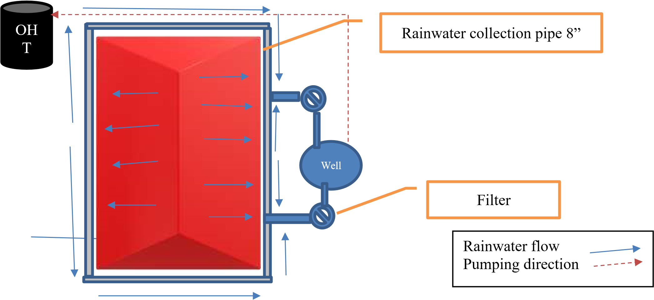

Option 2: Large Capacity Sump

Collect rain water from the Palletizer ware house be collected from both sides of the roof and delivered through a 8” pipe through a filter into 2 underground sumps. Total capacity of the sump is estimated at 800 m³. Two storage tanks of 400 m³ capacity tanks can be installed as shown in diagram 2. Dimension of each tank 20 m length, 10 m wide and 2 m depth. Rainwater collected is pumped through a underground pipe system to an overhead tank to supply the wash room and customer area facilities. The over flow from the tanks can be directed to the well for recharging.

Diagram 2 Schematic Diagram of the Proposed Rainwater Harvesting System with Underground Storage sumps

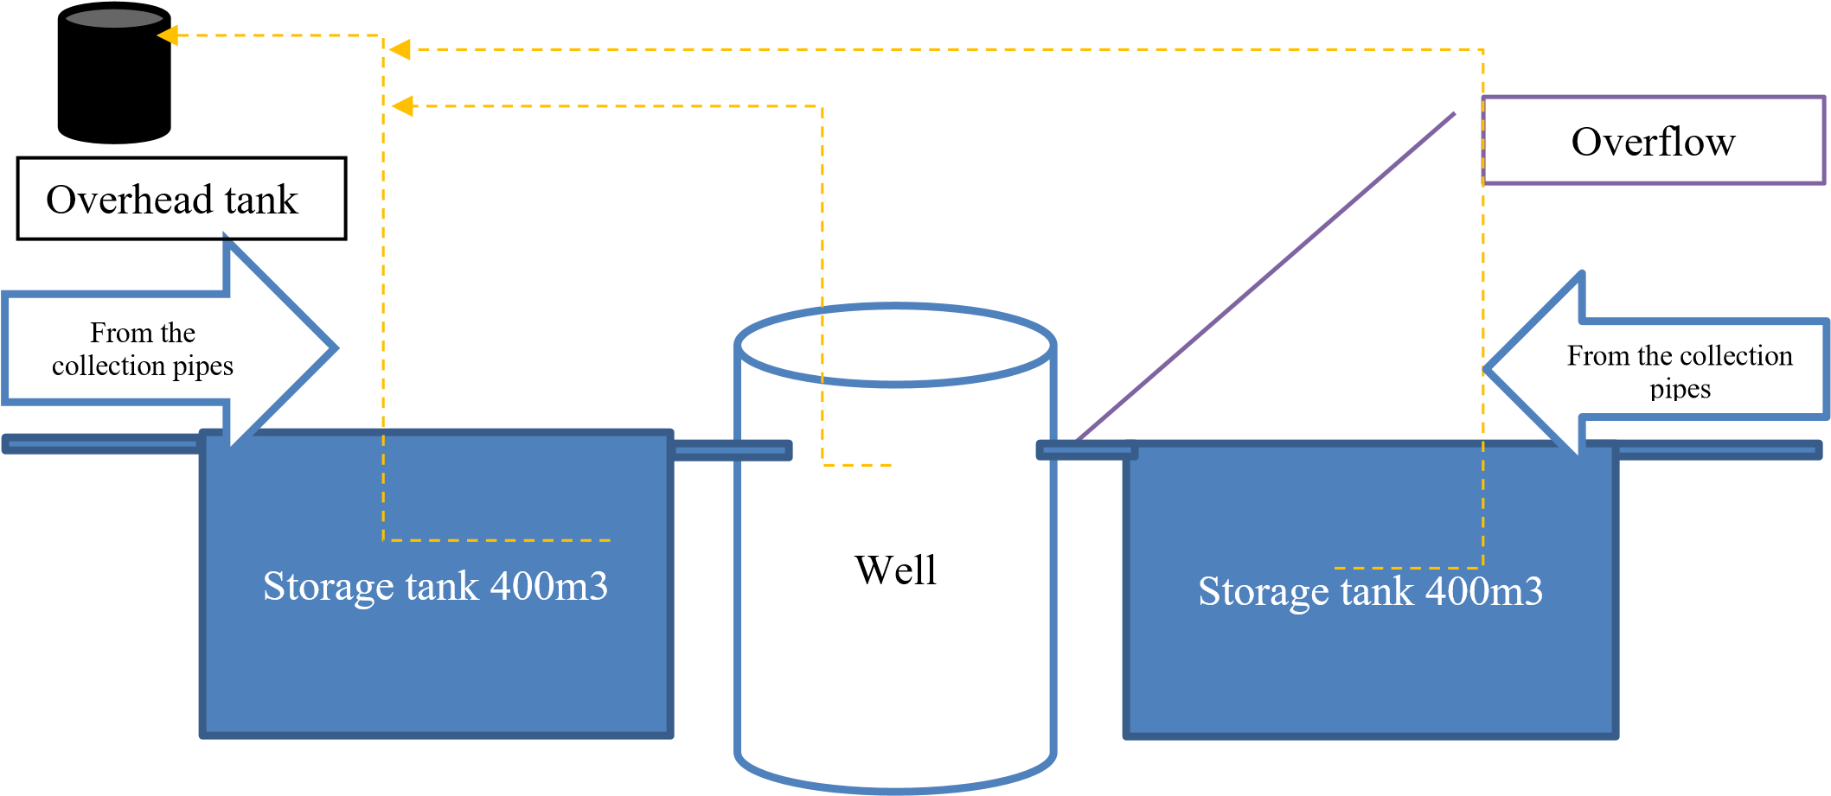

Option 3 Above Ground Storage Tank System

Roof run off from the changing room building can be collected into a number of PE tank of 10 m³ capacity placed by the side of the building and distributed to the overhead tank on this building. Since the roof area of the building is not known, it is estimated to be around 200 m², therefore annual run off would be 360m³. Average monthly run off is 30 m³. Maximum monthly run off is 50m³ during October. Therefore 3 or 4 PE tank of 10 m³ capacity is sufficient to collect the runoff water from this roof.

Diagram 3: Schematic Diagram of the Proposed Rainwater Harvesting system at the washroom Building roof

First flush

OH
T

Suggested filers for the Rainwater Harvesting System
Although rainwater is the purest form of water the roof and gutters of a building are not a sterile environment – therefore rainwater will pick up moss, dirt, leaves, bird faeces etc. on its way to the tank. After rainwater is collected from a roof, it should be filtered before it is stored in a tank. This is to ensure that it is kept in the best possible condition, to avoid degradation of biological material, development of odors etc.
It is therefore essential to install an adequate filtration system, and in some cases additional treatment, to ensure that the stored rainwater can be used effectively and safely.
Rainwater filters are designed for either one of the two primary purposes in a rainwater harvesting system:
Pre-tank treatment, which remove as many physical contaminants as possible before the water enters the storage system
In-tank filtration is a variation on pre-tank systems that see the filter deployed inside the storage tank but with the same effect as external pre-tank filters
Post-tank filtration involves additional particulate filtering after the water leaves the storage system and is piped to application points, such as drinking water outlets
Figure 4
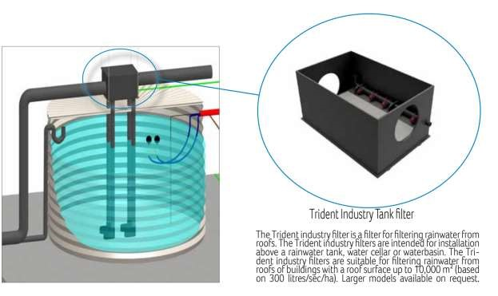

For more details: https://www.regenwater.com/en/gebruikregenwater/watersystems/rainwater/rainwaterfilters/trident-tankfilters/rainwaterharvestingfilter

Disinfection:
While mechanical filters are effective at removing particles from water, they cannot remove bacteria. This is not an issue if the water is to be used just for WC flushing, washing machine use and garden watering. However, if the rainwater is also destined for personal use; drinking, showering, etc. or if there is a risk of water vapor being ingested (e.g. spray irrigation at a garden center or nursery), then disinfection is an essential additional step. There are several methods of doing this, such as chemical dosing, Reverse Osmosis (RO) or Ultra-Violet light (UV). RO systems tend to be expensive and waste a lot of water, and dosing systems rely on using hazardous chemical (e.g. chlorine). So the most common method is UV disinfection, being both safe and reliable if properly maintained.
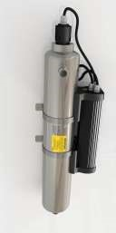

Figure 5

