**DESIGN OF RAINWATER HARVESTING SYSTEM FOR NOBLESWEAR (PVT) LTD., HORONA,**

**SRI LANKA**

September 2022

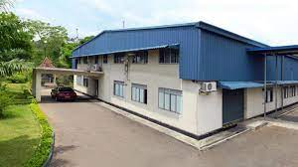

By Lanka Rain Water Harvesting Forum, September 2022

### General Information about site selection:



### Site Location: Nobleswear (Pvt) Ltd., Henegama, Pokunuwita, Horana Sri Lanka

### Roof area of the 5 large buildings:4354 m2

### Annual Rainfall for Horana: 1325.70 mm

### Total Monthly water demand: is 1095 m3 (as per NWS&DB May Month bill)

### Rainwater usage: Toilet flushing and washing



### Rainfall for Horana



Chart 1 Source: [www.weather-atlas.com](http://www.weather-atlas.com)

### Catchment Calculation

|  |  |  |
| --- | --- | --- |
| **Area** | **Square Feet** | **Square Meters** |
| Main Sewing Floor | 29,169.16 | 2710 |
| Canteen | 3,217.50 | 299 |
| RM Warehouse & Embroider Section | 6894.85 | 641 |
| Accounts & Sample | 2,865.21 | 266 |
| Merchandising & Pattern | 2,043.06 | 190 |
| Mechanic Room | 231 |  |
| Sample Guard Room & Storage Area | 168 |  |
| Compressor Room | 239 |  |
| Generator Room - Old | 357 |  |
| Generator Room - New | 300 |  |
| Stain Removing Room | 60 |  |
| Diesel Storing Room | 60 |  |
| Total | 45,604.78 | 44190 |

Table

### Runoff potential from Large Roofs in the Premises



### 

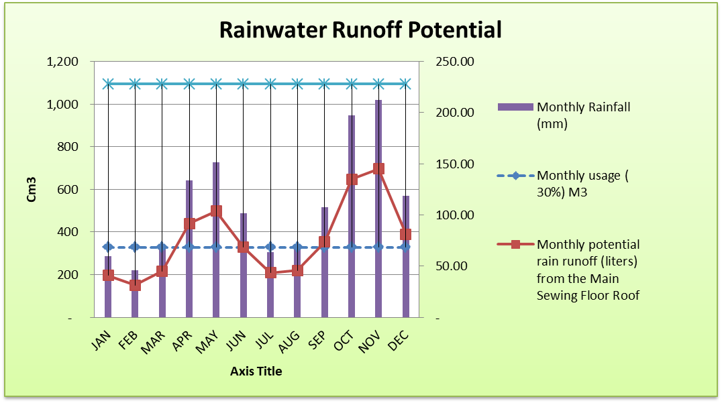Table

Chart 2

### Feasibility of Rainwater Harvesting at Nobleswear Horana premises



### 

### The total Annual run off potential from 5 large building are: 4344m3 or 4,344, 400 liters

### The total annual demand is: 13,140 m3 of 13, 140, 000 liters.

### Therefore, the total demand cannot be met through rain water harvesting alone.

### 30% of the total demand is calculated as 329 m3 or 329,000 liters per month and 3,942m3 per year

### Since the 30% of the total demand for the year is below the potential run off of 4344 m3 it can be met through rain water harvesting.

### C:\Users\Tanuja-PC\Downloads\Nobleswear.jpg

rain flow direction



Collecting Drains

 proposed underground storage tank

 Collection pond

**Figure 1 Site layout and Proposed Rainwater Collection System**

### According to the site layout and water usage requirement 2 option are recommended (Figure 1). All 2 option can be implemented together or at different stages.

### Option 1: Rainwater Collected from roof of Warehouse and Embroidery section

### Annual run off from Warehouse and Embroidery section: 679,344 liters or 679 m3

### Average Monthly run off: 56,612 liters or 56.8 m3

### It is proposed to build a underground sump of 50 m3 capacity at the rear side of the building as shown in figure 2 and connect it to the existing drain bringing collect roof run off from both side of the building. The existing man holes can be used to filter any debris coming from the roof (see annex 1)

The storage tank can be built by concrete or by installing 5 x 10 m3 PE tanks in a brick layered underground chamber.

Over head tank

Distribution

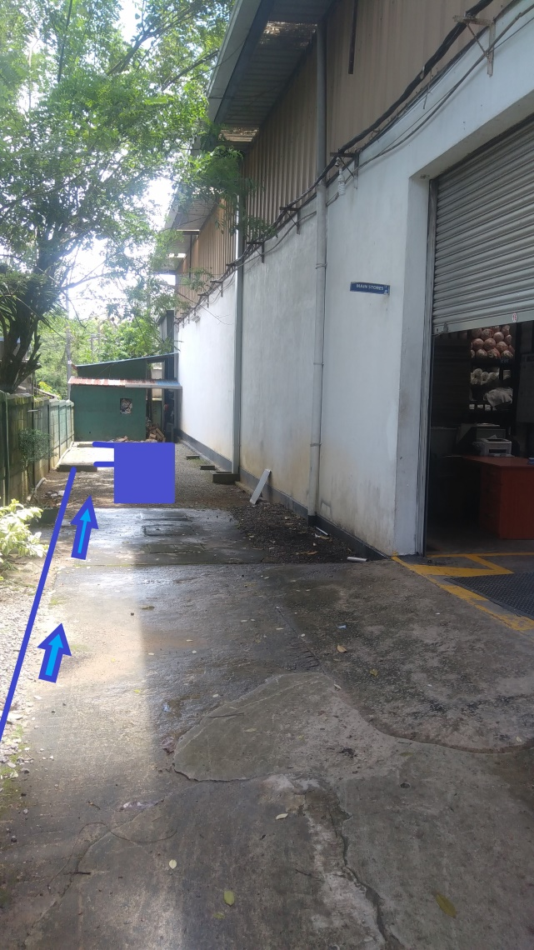

2.5 m

12 m

Dimension of the underground tank “Length 12.5 m, width 2 m, height 2 m, Volume 50 m3

Alternate Tank Arrangement with PE Tanks in a brick layered underground chamber

Inflow

Overflow

Man hole

Man hole

Storage tank

F**igure 2 location of the underground storage tank and feeding drains and Schematic Diagram of the Tanks**

Storage capacity of 50 m3 will provide minimum of 50,000 liters per month for 10 month of the year remaining 2 months more than 75% of the demand, as per feasibility calculation below.

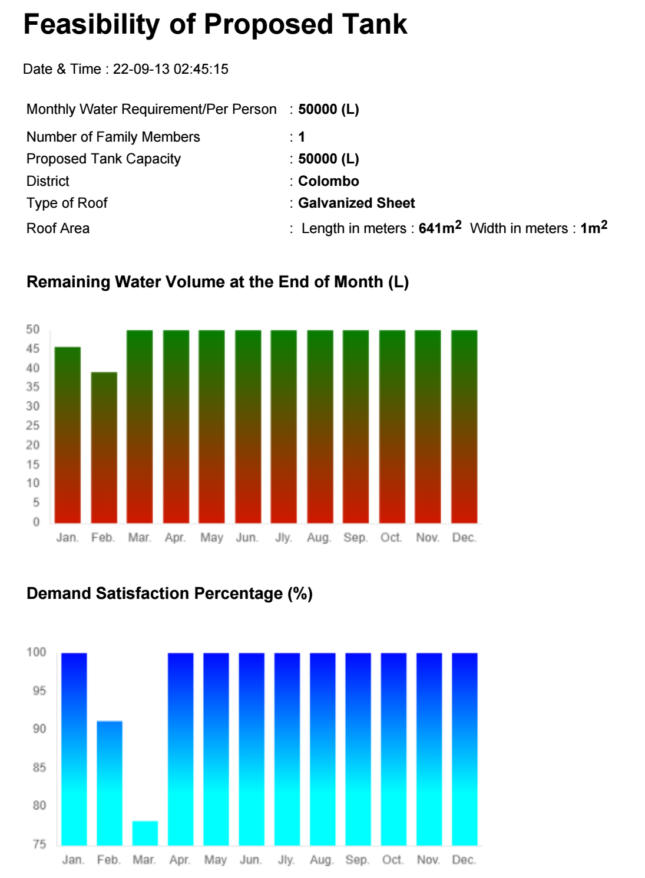

**Option 2 Rainwater Collected from roof of Main Sewing Floor and other Roofs**

Rainwater runoff from the main sewing floor and other roofs coming down the gutters which drains into the drainage system can be directed to a pond excavated into the adjoining marshy land (Figure 3). However, any drainage from kitchen waste or washing room should not drain into this pond as this would cause pollution and promote algae formation due to nutrient loading.

The highest run off expected from these roof is 587,909 liters (or 587 m3) during November month. Average monthly run off is 305,360 liters. The recommended volume of the pond is 300,000-350,000 liters or 300-350 m3.

To construct these small lakes, the FAO Manual on small earth dams (http://www.fao.org/docrep/012/i1531e/i1531e00.htm), which can be down loaded from the Internet free on small lakes is recommended. The FAO hand book gives the volume of a small lake as:

**1/6 x length x width height of the Dam.**

To construct a Dam use of earth will be most economical. However, in constructing an earthen dam attention should be made to the following:

• An over flow should be big enough prevent any spill over the earthen dam

• Toe of the earth dam should have a toe filter to prevent the toe eroding. (Figure 4)

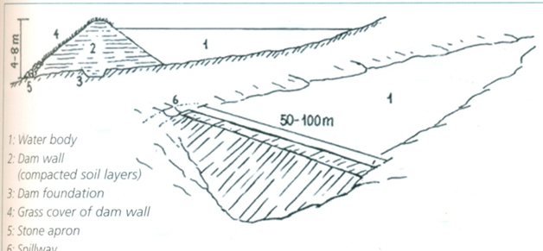

**Figure 3 Small Earth Dam**

Fine Sand

Coarse sand

Stones ¾”

Boulders 2”

Boulders 9”

**Figure 4 Detail of Toe Filter of an Earthen Dam**



**Important Notes**:

1. Since this is a residential area and prone to dengue mosquitoes breeding, adequate precaution need to be taken, such as to rear fish in the ponds to prevent mosquitoes larvae breeding.
2. Adequate precaution need to be taken to prevent any persons or animals falling into the water.
3. During heavy rain the pond can over flow and cause folding in the area, therefore overflow has to be adequate

**Annex A Different types of Filters that can be adopted.**

There are various types of filters which are commercially available. Some examples are as below.

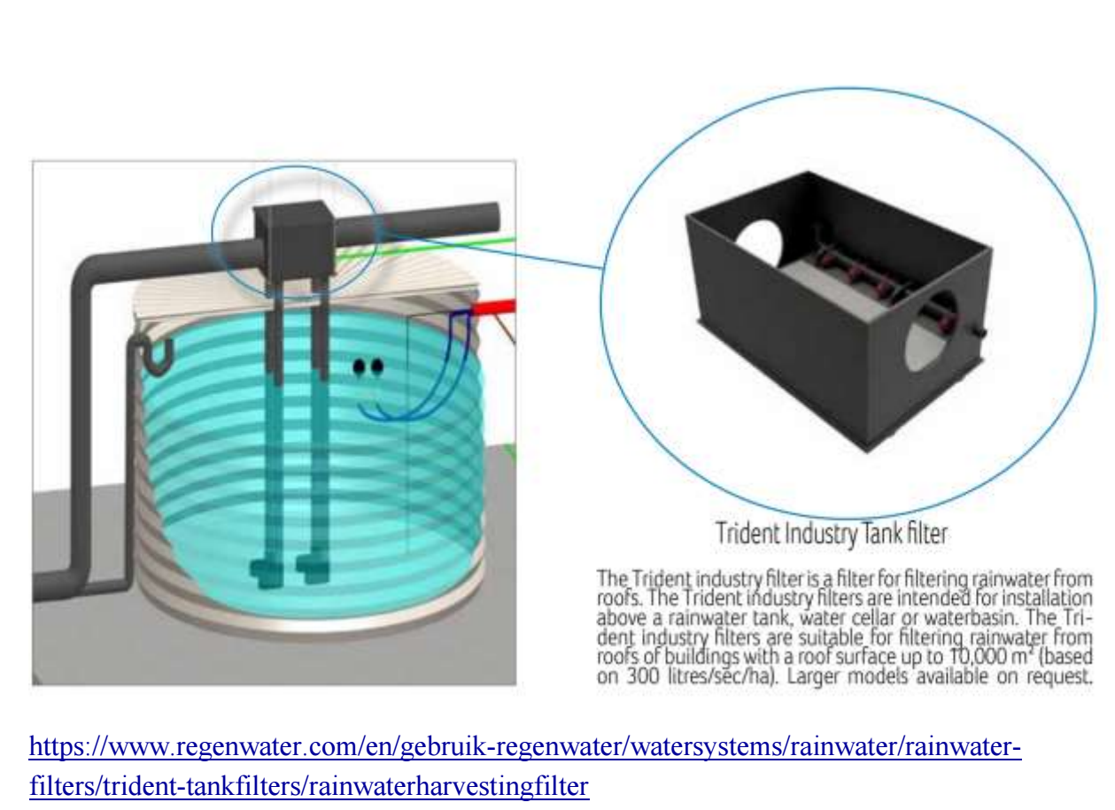

**Figure 5**

<https://www.homedepot.com/p/4-in-Inlet-Outlet-Compact-Rainwater-Harvesting-Filter-311000100/301907537#overlay>

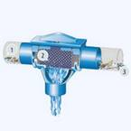

**Figure 6**

However, they are not available in the Sri Lankan market and they are expensive. Below are some options that can be adopted.

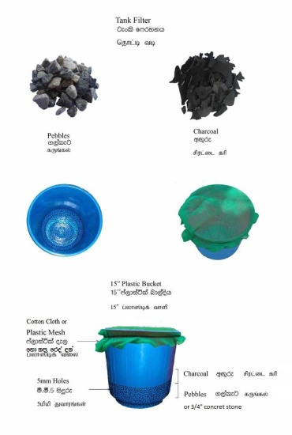Filter basin at the Man holes near down pipes

Filter basin

Filter system at the Manhole on the drainage system

Stainless steel sieve

A removal pipe of 6” -8” diameter containing filter media of different sizes (as diagram below) can be install inside the manholes on the drainage system. These should be removable for maintenance purposes.

