DESIGN OF RAINWATER HARVESTING SYSTEM FOR MAS INTIMATES
UNICHELA BIYAGAMA

 | Roof Area | 6000 m²
 | Capacity of the water tank | 10,000 liters
 | Rain fall band | Colombo district.

Water needs per day (average) = Cooling tower and Consumption
= 64.0 m³
= 64,900 liters

 | Work Days
 | 23 | 20 | 26 | 18 | 26 | 27 | 26
Meter | January | February | March | April | May | June | July
Main Meter (Units/m³) | 52.4 | 52.6 | 55 | 54.4 | 48.5 | 58.6 | 56.6
Cooling Tower (Units/m3) | 10 | 11.2 | 10.1 | 11.5 | 9.8 | 13.4 | 10.2
Total (Units/m3) | 62.4 | 63.8 | 65.1 | 65.9 | 58.3 | 72 | 66.8
Total Average |  |  |  |  |  |  | 64.9
Cooling Tower only average |  |  |  |  |  |  | 10.9
Table 1 Works Days

According to the site layout and water usage requirement 3 option are recommended (Figure 1).

OPTION 01

Use of Rainwater for gardening only

Collect rainwater from front left hand side of the main entrance and store in underground sump. Capacity of the tank will depend on the daily water requirement. A sump of 10 m³ will be adequate to water plants for 20 days dry period. Water can be taken put through the immersion pump for watering the plants. Estimate cost of the system Rs. 350,000

OPTION 02
Use of Un-used sump

Unused pump (capacity not know) can be used to store roof run off back end of the left side of the building. This water can then be used for gardening, toilet flushing or for water cooling tower. Estimate cost Rs. 100,000
OPTION 03

Large capacity sumps

Large capacity sumps (see recommended capacity) can be build underground on the right hand side of the building. The collected rain water from one side of the roof can then be pumped to a overhead tank and can be used for gardening, toilet flushing, cooling tower ect.
Result of Roof Run off Calculation simulation model using Rainwater tank performance calculator developed by Warwick University UK

Water management strategies

Three water management strategies are looked in order to get the most reliable, efficient and satisfactory rainwater harvesting system.
- Constant Demand
The user draws a set amount of water from the tank every day if there is enough in there to do so, otherwise the user takes what is left in the tank

- Varies with tank content
The user draws off an amount dependant on the volume of water in the tank. If the tank is between one-third and two-thirds full, the user takes the nominal demand that you specified from the tank. If the tank is more than two thirds full, the user draws off more water than usual, but if the tank is less than one third full, the user takes less water than normal. This water conservation means that system reliability is improved for a given tank size
- Varies with season
The user takes more water from the tank if it has rained recently and less when it has not. This aids water conservation and increases system reliability for a given tank size.

Notes
- Reliability is the fraction of days the total demand will be met by the system
- Satisfaction is the fraction of the total water demand that can be met by the system
- Efficiency is the fraction of the runoff from the roof captured by the system
- The comparison tank volumes are based on the average daily roof runoff multiplied by 5 days, 20 days and 80 days respectively
- The calculated nominal demand is set at the mean daily runoff
- Compares the typical cost of each comparison tank with that of your tank size
Your Results

- Constant Demand

Location | Colombo
Roof area | 6000 m²
Nominal demand | 64900 litres
Mean daily runoff | 32019 litres
Water management strategy | Constant Demand

Using the nominal demand and tank size that you specified of 64900 litres per day:

 | Your Tank | Comparisons
Tank Volume (litres) | 10000 | 160100⁴ | 640400⁴ | 2561500⁴
Reliability¹ | 14% | 17% | 33% | 39%
Satisfaction² | 9% | 28% | 42% | 48%
Efficiency³ | 18% | 56% | 85% | 95%
Table 2 Using the nominal demand and tank size that you specified of 64900 litres per day
Using a calculated⁵ nominal daily demand of 32019 litres per day:

 | Your Tank | Comparisons
Tank Volume (litres) | 10000 | 160100 | 640400 | 2561500
Reliability | 21% | 39% | 64% | 81%
Satisfaction | 14% | 48% | 68% | 83%
Efficiency | 14% | 48% | 68% | 82%
Table 3 Using a calculated5 nominal daily demand of 32019 litres per day

Relative costs:
:

 | Your Tank | Comparisons
Tank Volume (litres) | 10000 | 160100 | 640400 | 2561500
Relative cost⁶ | 1.0 X | 4.6 X | 9.9 X | 21.1 X
Table 4 Relative costs

- Varies with tank content.
Location | Colombo
Roof area | 6000 m2
Nominal demand | 64900 litres
Mean daily runoff | 32019 litres
Water management strategy | Tank Level

Using the nominal demand and tank size that you specified of 64900 litres per day:
:

 | Your Tank | Comparisons
Tank Volume (litres) | 10000 | 160100⁴ | 640400⁴ | 2561500⁴
Reliability¹ | 11% | 13% | 41% | 56%
Satisfaction² | 11% | 35% | 57% | 66%
Efficiency³ | 20% | 58% | 88% | 96%
Table 5 Using the nominal demand and tank size that you specified of 64900 litres per day:

Using a calculated⁵ nominal daily demand of 32019 litres per day:
:

 | Your Tank | Comparisons
Tank Volume (litres) | 10000 | 160100 | 640400 | 2561500
Reliability | 19% | 38% | 73% | 88%
Satisfaction | 18% | 60% | 82% | 93%
Efficiency | 16% | 52% | 75% | 87%
Table 6 Using a calculated5 nominal daily demand of 32019 litres per day:

Relative costs:
:

 | Your Tank | Comparisons
Tank Volume (litres) | 10000 | 160100 | 640400 | 2561500
Relative cost⁶ | 1.0 X | 4.6 X | 9.9 X | - X
Table 7 Relative costs:
- Varies with season.

Location | Colombo
Roof area | 6000 m²
Nominal demand | 64900 litres
Mean daily runoff | 32019 litres
Water management strategy | Seasonal

Using the nominal demand and tank size that you specified of 64900 litres per day:
:

 | Your Tank | Comparisons
Tank Volume (litres) | 10000 | 160100⁴ | 640400⁴ | 2561500⁴
Reliability¹ | 13% | 15% | 28% | 33%
Satisfaction² | 8% | 25% | 39% | 43%
Efficiency³ | 19% | 57% | 89% | 97%
Table 8 Using the nominal demand and tank size that you specified of 64900 litres per day:

Using a calculated⁵ nominal daily demand of 32019 litres per day:

 | Your Tank | Comparisons
Tank Volume (litres) | 10000 | 160100 | 640400 | 2561500
Reliability | 21% | 37% | 59% | 75%
Satisfaction | 13% | 45% | 66% | 79%
Efficiency | 15% | 51% | 73% | 87%
Table 9 Using a calculated5 nominal daily demand of 32019 litres per day:

Relative costs:
:

 | Your Tank | Comparisons
Tank Volume (litres) | 10000 | 160100 | 640400 | 2561500
Relative cost⁶ | 1.0 X | 4.6 X | 9.9 X | 21.1 X
Table 10 Relative costs:

How to interpret the Data
A high 'reliability' means that for most of the year the householder will not need to fetch extra water from another source. A high 'satisfaction' means that most of the household's water can come from its RWH tank. A high 'efficiency' means that most of the roof run-off is being used, little is being wasted by overflowing the tank and we can say that performance is 'roof limited'.
Most owners of RWH systems have greatest interest in supply 'reliability', so that measure is generally the most useful of the three. RWH systems do not generally give 100% reliability, because to do so they would have to access a very large roof and contain an extremely large tank. Normally performance is either roof-limited or tank-limited. For most establishments it will be most economic to size the tank to give between 60% and 80% reliability and to buy or fetch water from other sources for part of each dry season.
To improve the performance of a RWH system there are four main options:
- increase the tank size (however each time you double the tank size you increase system cost by about 60%);
- reduce the nominal daily demand to well below mean daily runoff - (this will increase reliability but reduce the total water drawn and hence the system efficiency).
- change to a more effective management strategy (from a fixed daily demand to one that is varied, with either tank water content or with season, to conserve water in the dry season).

According to the above results,
- Tank size of 10,000 liters will give you 18% reliability and 09% satisfaction. This is because the daily demand is high 64,900 liters and daily run off is only 32, 019 litres.
- Even if the demand is reduced to 32, 019 liters then a tank of 640,400 liters will give above 60% reliability. This is not feasible since the cost of such capacity tank is too high.
Therefore, it is better separate out the water need, gardening, toilet flushing, or cooling tower and then determine the tank size accordingly.

Fist Flush system or filter System
It is better to have a first flush system and/or a debris filter to prevent any contamination from the roof get in to the tank.
Generally, the first 2mm of rain is recommended to be discarded. Therefore a roof size 3969 m² will need to discard nearly 8000 liter of water. This water can be used for gardening purposes.
A filter can be screen on stainless steel mesh, placed at the inlet to the tank to prevent any small particles entering the tank.

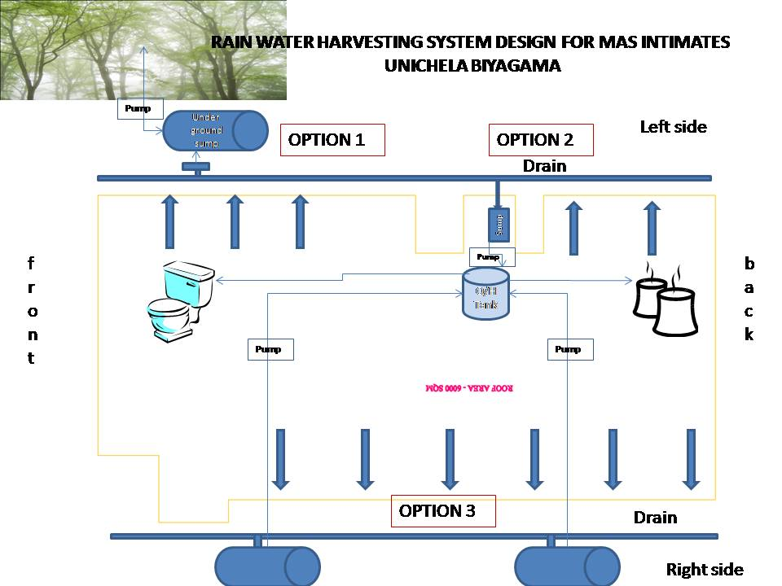
Figure 1 Rain Water Harvesting System Design for Mas Intimates Unichela Biyagama

http://www.eng.warwick.ac.uk/dtu2/rwh/model/inputs2.phtml

