Recommendation for Installing a Rainwater Harvesting System for Mahinda Rajapaksa Sport Center Hostels

4th April 2012
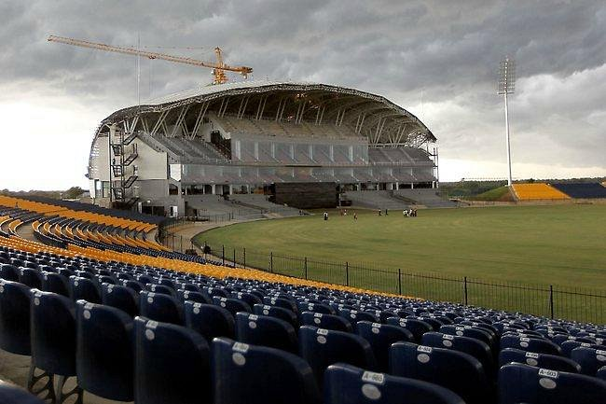
Introduction:

A request was made to Lank Rain Water harvesting Forum by Dr Manel Dissanayake on the 14th March 2012 to give a proposal to implement a Rain Water Harvesting system at the Mahinda Rajapaksa Sport complex at Diyagama, Kottawa.
Following this request LRWHF Director Dr Tanuja Ariyananda, visited the site on the 20th March 2012 and met Captain Priyanka Alwis, Architect and Mr Tudor Agriculture Officer.
Locations visited: New Hostel area, Vegetable plots, Ponds.

It was requested to design a Rain Water System for the Hostel use and as well as gardening around the area.
Designing of Rain Water Harvesting System
Year | Jan | Feb. | Mar | Apr | May | Jun | July | Aug | Sep | Oct | Nov | Dec.
2000 | 57.9 | 0 | 36.4 | 119.8 | 199.3 | 256.3 | 482.2 | 127.8 | 209 | 304.1 | 267.3 | 327.6
2001 | 102.4 | 177.9 | 79.3 | 168.5 | 207.5 | 229.8 | 31.6 | 249 | 312.3 | 282.6 | 52 | 119.5
2002 | 187.3 | 142.4 | 81.3 | 243.9 | 205.1 | 173.6 | 73.1 | 2.5 | 263.6 | 166.4 | 229.8 | 163.6
2003 | 46.1 | 96.4 | 42.3 | 296.4 | 972 | 69 | 18.2 | 42.5 | 140.3 | 445.2 | 299.5 | 261.8
2004 | 137.5 | 89.3 | 164 | 95.9 | 284.8 | 181.6 | 185.7 | 77.1 | 247.8 | 0 | 374.4 | 6.6
2005 | 8.5 | 60.1 | 30.9 | 70.9 | 232.8 | 191.3 | 124.8 | 138.4 | 356.7 | 363 | 264.1 | 116.6
2006 | 167 | 8.6 | 120.3 | 212.4 | 285.6 | 220.2 | 165.8 | 21.8 | 85.3 | 5.4 | 760.4 | 262.6
2007 | 126.9 | 156.9 | 266.6 | 103.4 | 193.1 | 183.1 | 96.8 | 270.6 | 129 | 619.9 | 524.7 | 51.9
2008 | 91.1 | 9.9 | 60.5 | 374.1 | 432.4 | 79.9 | 106.6 | 260.5 | 129.3 | 292.1 | 128.8 | 119.6
2009 | 30.6 | 118.5 | 293.7 | 435.9 | 170.6 | 250.5 | 185.8 | 140.1 | 155.2 | 491.6 | 140.9 | 0
Colombo Rain Fall for 10-year period
Table 1

Roof Area of Hotel of one side: 20.122 m x 1536 m =30907 m²

Water requirement: =12 room x 8 per room = 75 person
= approximately 100 liter per person per day
= 100 x 75 = 7500 liters per day

Calculation of Tank Volume
Colombo, Diyagama
Location
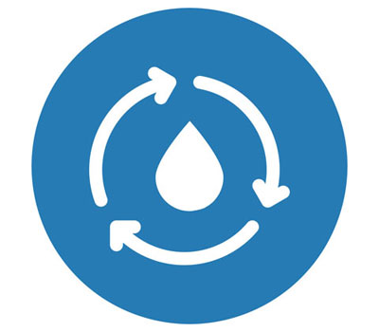
30907 m²
Roof area

7500 litres
Nominal demand

162819 litres
Mean daily runoff

Constant Demand
Water management strategy

Results

Using the nominal demand and tank size that you specified of 7500 litres per day:
 | Your Tank | Comparisons
Tank Volume (litres) | 100000 | 814100⁴ | 3256400⁴ | 13025500⁴
Reliability¹ | 87% | 100% | 100% | 100%
Satisfaction² | 88% | 100% | 100% | 100%
Efficiency³ | 4% | 5% | 5% | 5%

Using a calculated⁵ nominal daily demand of 162819 litres per day:
 | Your Tank | Comparisons
Tank Volume (litres) | 100000 | 814100 | 3256400 | 13025500
Reliability | 22% | 39% | 67% | 82%
Satisfaction | 17% | 49% | 70% | 84%
Efficiency | 17% | 49% | 70% | 84%
Table 2

Relative costs:
 | Your Tank | Comparisons
Tank Volume (litres) | 100000 | 814100 | 3256400 | 13025500
Relative cost⁶ | 1.0 X | 3.2 X | 6.8 X | 14.6 X
Table 3
Notes
- Reliability is the fraction of days the total demand will be met by the system
- Satisfaction is the fraction of the total water demand that can be met by the system
- Efficiency is the fraction of the runoff from the roof captured by the system
- The comparison tank volumes are based on the average daily roof runoff multiplied by 5 days, 20 days and 80 days respectively
- The calculated nominal demand is set at the mean daily runoff
- Compares the typical cost of each comparison tank with that of your tank size

Proposed Rain Water Harvesting System for Mahinda Rajapaksa Sport Center Hostels
Hostels

Proposed Hostel Building
Canteen
Toilets
Distribution line
Run off
Garden
Over head tank

Recommendation

It is recommended to collect the run off from one side of the hostel building only. The run off from the roof coming down the gutters can be directed to a under ground tank of 2 m³ as the first flush tank, which will collect all the debris and dust from the roof and to be discarded. The balance filtered water can go to a bigger under ground storage tank (as in Figure).
Under ground tank of 100 m³ will give the present requirement of 7500 liters per day for hostel use. However, the system is capable of giving higher service level. For example, a daily demand of 162,819 liters can be met with a bigger tank such as 814,100 liters (814 m³). But you will have to compare it with price which would be nearly 7 times.

It is recommended that 100 -200 m3 tank is for the present requirement leaving space to add on new tanks if the requirement increase.

Other recommendation for site

- Contour map the site and cut continuous contour trenched to arrest the run off and increase seepage to the soil. This will increase the soil moisture and levels in the water table.
- Collect run off from the hostel side into large open pond ( like near the stadium), this can be used for agriculture purposes as wells as increase water levels in the well.

