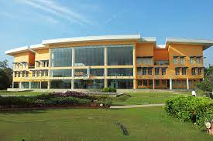
Rainwater Harvesting at Millennium Information Technologies Ltd., Malabe

Location

Millennium City, Malabe, a state-of-the-art software company situated about 40 Km from Colombo city. About 200 workers occupy the complex and consists of a 12,000 m² facility developed on a 6.5 ha sloping site.
Figure 1 Millennium Information Technologies Malabe
Need
- Initial occupation: 300 pax
- Estimated max. demand for water (incl. swimming pool and landscaping): 150 m³ per day
- Projected occupation: 600 pax/ projected demand: 195 m³ per day
Demand

Demand Composition at Millennium IT Campus
 | Initial  (300 pax) | Future  (600 pax)
Water of drinking quality  (for washbasins, showers, swimming pool) | 40 m³/d | 69 m³/d
Water for toilet flushing – harvested rainwater | 22 m³/d | 38 m³/d
Water for landscaping (recycled waste water and stored surface run-off water) | 88 m³/d | 88 m³/d
Total demand | 150 m³/d | 195 m³/d
Table 1 Demand Composition at Millennium IT Campus

How the demand is met?

Demand Composition at Millennium IT Campus
 | Immediate  (300 pax) | Future  (600 pax)
Water of drinking quality  (for washbasins, showers, swimming pool) | 40 m³/d | 69 m³/d
Water for toilet flushing – harvested rainwater | 22 m³/d | 38 m³/d
Water for landscaping  (recycled waste water and stored surface run-off water) | 88 m³/d | 88 m³/d
Total demand | 150 m³/d | 195 m³/d
Table 2 Demand Composition at Millennium IT Campus

Design of Rain water harvesting system

- Rainwater from a roof area of 5,525 sqm of 3 major buildings is collected (except from roof gardens) ...
Figure 2
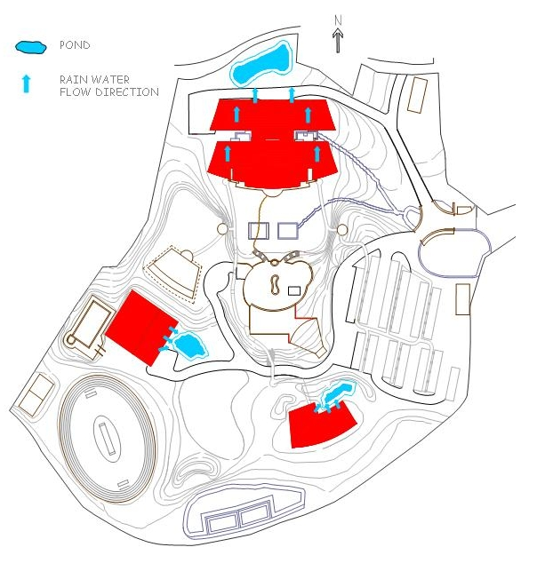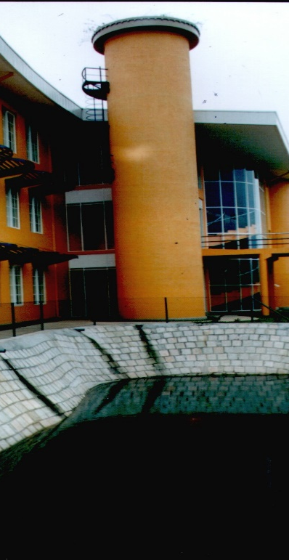

- ... and stored in three ponds with a volume of 2,315 m³
- the system is designed for a 90-day dry period
- These rainwater ponds are part of the landscaping of the complex
- Ponds are constructed using HDPE foils and are finished with block work
- harvested rainwater from the ponds reaches the pump & filter units by gravity

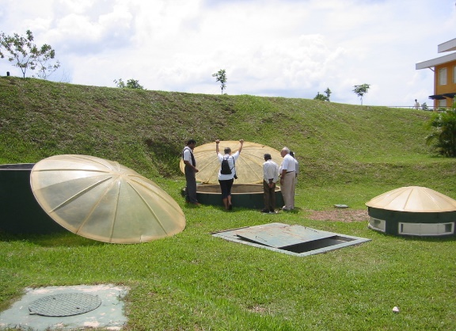 | 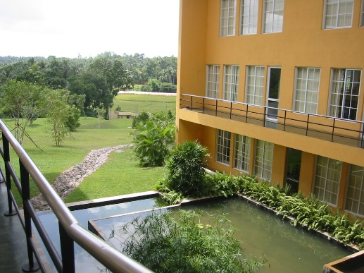
Storage tanks | Storage Ponds
Figure 3 Storage tanks and Storage ponds

- 2 systems (north and south) service the complex taking advantage of the topography of the site
- through pressurized pump systems water is supplied using a dedicated network: no connections to the drinking water supply system!
- Back-up system: provision to supply pump units with water from NWSDB network

Operation
Rain water meet about 70% of the water demand. Rainwater is used for toilet flushing, gardening and washing

Landscaping and recycling:
- All black & grey water of the campus is recycled to a quality suitable for landscaping...
- ... using a network of septic tanks and a central vertical flow filter with subsequent ponds
- the entire system is a gravity system
- The balance water requirement for landscaping purposes is met by collecting surface run-off in a pond of a volume of approximately 1,450m3 located at the lowest location of the complex
- the entire system is a gravity system

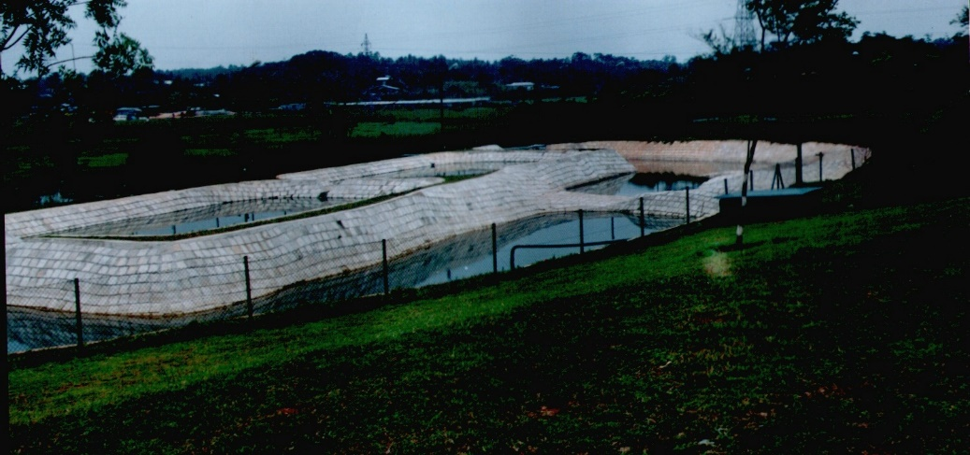
Figure 4

Benefits
- Rainwater harvesting combined with on-site effluent treatment and reuse of recycled water adds up to a water “saving” of 75 %
- The system assures that the interventions into the natural water cycle are virtually zero, as harvested water is finally used on-site for landscaping (with a time delay)
- Rainwater harvesting as a positive peak flow-reducing measure
- Considering the scarcity and value (... not yet cost ...) of clean water rainwater harvesting has the potential to contribute significantly to the protection and conservation of one of our most valuable resources - water

Extracted from the Paper presented at the by Arch. I. D. Kurupu, Synergetics Lanka (Pvt.) Ltd. at the Workshop held at the Ministry of Urban Development and Water Supply on “Rain in the City” organized by LRWHF 2004

