Rainwater Harvesting Potential at Haycarb Factory Premises at Madampe

January 2017
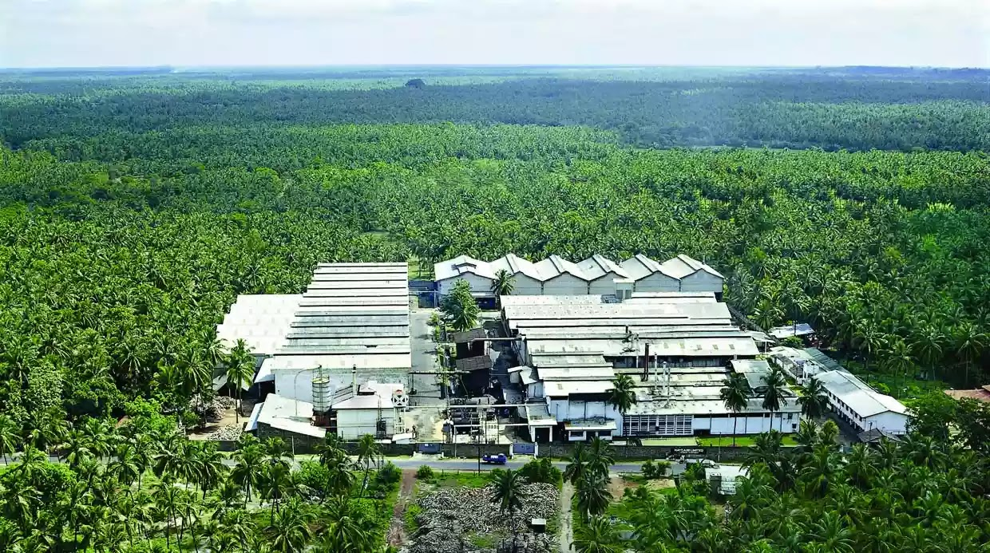

Introduction:
Following a request for a feasibility study to assess the potential of rainwater harvesting for the factory premises of Haycarb at Madampe, a visit was made by Dr Tanuja Ariyananda, CEO, of LRWHF on the 18th of January 2017 to the premises.
The following information was obtained
50 m³ (excluding drinking). For bathing and processing need
Daily Water Demand

2500m²
Roof Areas

4000 m²

Land Areas

Rs 400,000 (purchased from NWS&DB & Others @ Rs 0.09/liter)
Monthly water bill

Process water has to be deionized or softened for which facility is available on the premises.
Notes:
- A canal coming from the village crosses the factory
- A marshy land owned by the factory is located near the factory and storm water of other lands collected here.
- There is a possibility to acquire the adjacent marshy lands to construct storage facilities
Figure 1 Haycarb Factory Premises at Madampe

Rain Water Harvesting Potential Calculation:
Rain Fall Pattern for Madampe (source /weather-and-climate.com/)

Chart 2 Rain Water Harvesting Potential Calculation
STEP 1- Catchment Area Calculation

Type of  Catchment | Area  (Sqm) | Runoff  Coefficient | Area x Runoff Coefficient
Roof | 25,000 | 0.85 | 21,250.00
Land | 40,000 | 0.60 | 24,000.00
Table 1

STEP 2 - Runoff potential as per annual rainfall
Annual rainfall  (mm) | Total RWH  potential  (Liters) for Roof | Total RWH  potential  (Liters) for Land | Total potential (Liters) from all the catchment area
1,508 | 32,042,875 | 36,189,600 | 108,781,000
Table 2

Storage Potential as per Catchment Variation

Chart 2 Storage Potential as per Catchment Variation

STEP 2 b)- Runoff Potential (Monthly) from Roofs Only

Months | Monthly Rainfall (mm) | Monthly potential rainfall (liters)Roof of 25000 m2 | Total potential volume of water (Meter cube) collected | Monthly Demand (Meter Cub) for 22 working days | Monthly Surplus/ (Defecit ) | Percentage of demand Not met
JAN | 33.6 | 714,000.00 | 714.00 | 3,300 | (2,586.00) | (78.36)
FEB | 52.1 | 1,107,125.00 | 1,107.13 | 3,300 | (2,192.88) | (66.45)
MAR | 68.9 | 1,464,125.00 | 1,464.13 | 3,300 | (1,835.88) | (55.63)
APR | 173.9 | 3,695,375.00 | 3,695.38 | 3,300 | 395.38 | 11.98
MAY | 194.9 | 4,141,625.00 | 4,141.63 | 3,300 | 841.63 | 25.50
JUN | 102.3 | 2,173,875.00 | 2,173.88 | 3,300 | (1,126.13) | (34.13)
JUL | 75.0 | 1,593,750.00 | 1,593.75 | 3,300 | (1,706.25) | (51.70)
AUG | 67.6 | 1,436,500.00 | 1,436.50 | 3,300 | (1,863.50) | (56.47)
SEP | 113.4 | 2,409,750.00 | 2,409.75 | 3,300 | (890.25) | (26.98)
OCT | 302.7 | 6,432,375.00 | 6,432.38 | 3,300 | 3,132.38 | 94.92
NOV | 247.9 | 5,267,875.00 | 5,267.88 | 3,300 | 1,967.88 | 59.63
DEC | 75.6 | 1,606,500.00 | 1,606.50 | 3,300 | (1,693.50) | (51.32)
 | 1,507.90 |  |  |  |  | (229.00)
Table 3 Runoff Potential (Monthly) from Roofs Only

Rainwater tank performance calculator:

Location | Madampe
Roof area | 25000 m²
Nominal demand | 150000 liters
Mean daily runoff | 89008 liters (59% of the demand)
Water management strategy | Constant Demand
Results
Using the nominal demand and tank size that you specified of 150000 litres per day:
 | Your Tank | Comparisons
Tank Volume (litres) | 4000000 | 445000⁴ | 1780200⁴ | 7120600⁴
Reliability¹ | 49% | 18% | 42% | 52%
Satisfaction² | 56% | 30% | 50% | 59%
Efficiency³ | 93% | 51% | 84% | 98%
Table 4
Using a calculated⁵ nominal daily demand of 89008 litres per day:
 | Your Tank | Comparisons
Tank Volume (litres) | 4000000 | 445000 | 1780200 | 7120600
Reliability | 77% | 36% | 67% | 87%
Satisfaction | 80% | 46% | 72% | 89%
Efficiency | 80% | 46% | 72% | 88%
Table 5
Relative costs:
 | Your Tank | Comparisons
Tank Volume (litres) | 4000000 | 445000 | 1780200 | 7120600
Relative cost⁶ | 1.0 X | 0.3 X | 0.6 X | 1.4 X
Table 6

Notes
- Reliability is the fraction of days the total demand will be met by the system
- Satisfaction is the fraction of the total water demand that can be met by the system
- Efficiency is the fraction of the runoff from the roof captured by the system
- The comparison tank volumes are based on the average daily roof runoff multiplied by 5 days, 20 days and 80 days respectively
- The calculated nominal demand is set at the mean daily runoff
- Compares the typical cost of each comparison tank with that of your tank size
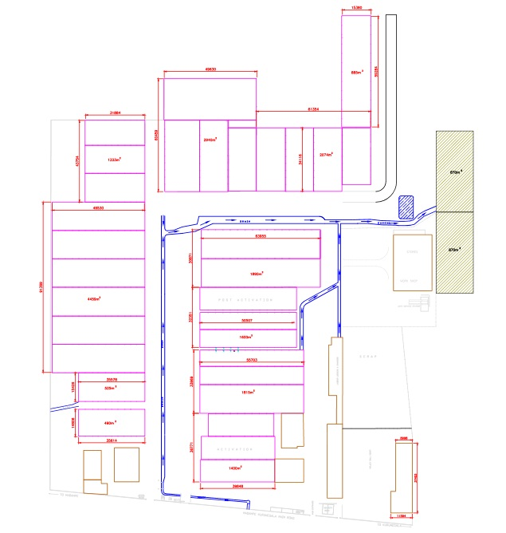
Storage Ponds
2000m³
2000 m³
Drain/ Canal
Roof Water
Drainage
First flush water diverter
Figure 3 Roof Water Drainage Direction and Plan for Rain Water Storage

Description of Proposed Roof Water Collection Plan

Calculation:

Daily demand: 150 m³
Monthly demand for 22 working days: 150m³ x 22 = 3,300 m³
Annual demand = 3,300 m³ x 12 = 39,000 m³
Annual Rain Water harvesting Potential from both Roof and land = 108,781,000 liter or 108, 782 m³
Annual roof water potential from roof only = 32,042,875 liters or 32, 042 m³

Option 1
There is a potential to cater for all the water requirement of the factory with adequate storage by collecting both roof water as well as land run off through the existing drainage system. The storage can be placed in the land behind the complex in the form of 2 ponds (open or closed) figure 1. However, if land run off is collected, water will have to be treated further to bring to usable quality, and additionally larger storage facilities will also be needed. Since drainage will be through the canal which comes from the village, there may be further impurities coming in the canal, of which there is no control, therefore adequate treatment system will have to be designed and installed after testing the water quality in the canal.

Option 2
However, if only roof water is collected, then 59% of the demand ( see Rainwater tank performance calculator above) that is daily 89, 008 litres ( 89 m3) can be met with storage of 4000 ^{m3} and quality of collected water could be controlled and managed to high standard.
Roof water can be collected through down pipes and delivered by a PVC/Concrete pipe of larger diameter (6-8 inched) which can be places inside the existing drain and canal as in the figure 1. PVC /Concrete pipe should be connected together and delver into a storage tanks placed in the location as in the figure 1. The storage tanks should be placed underground and preferably covered to prevent algae forming, evaporation and breeding of mosquitoes. If kept open, introduce fish to prevent mosquito breeding. The ponds can be lined with pond liner to prevent seepage to the ground. Storage should be done in 2 tanks of equal volume (2000 m³ each) for easy maintenance work etc.
To prevent any dust particulates’ deposited in the roofs entering into the storage tanks, the first rain should be discarded. This can be done by directing the first 2mm of rain (50 m³ volume) into the pond located near the storage tank. Over flow from this pond can be directed to the storage tank. Alternatively, there are Vortex filters available in the market which can be fitted into strategic locations in the drainage network (annex 1 Vortex filter). They cost around Euro 4000, for a 3000 m² roof area (about 8 filters will be needed for your roof area).
Annex 1 ( http://actwisy.in/products/pre-filter/vortex-filter/wff-300)

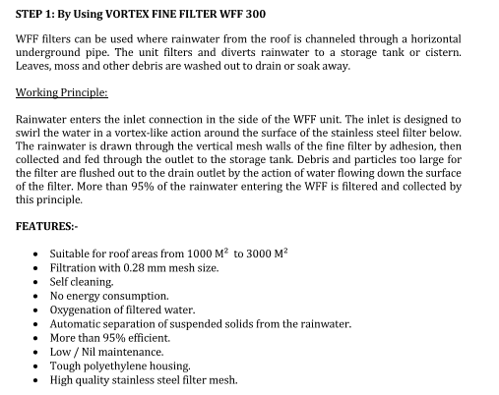
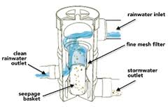
Figure 4

