RWH Design for Lalan Rubber Plantation
Kurunegala Distirct
By
Lanka Rain Water Harvesting Forum

A visit was made by Dr Tanuja Ariyananda, Director Lanka Rain Water Harvesting Forum ( www.lankarainwater.org) to the Lalan Rubber Pvt Ltd at Kurunegala district at the invitation of its Manager The objective of the visit was to assess the potential for run off rainwater harvesting collection for the plantation.
Problem: Drop in yield by 40% during dry season due to reduction in soil moisture content.

Description of the locations

- Kapetigala ( Malabe Division): sloping land below the bungalow. Steep slope about 45⁰ . This area is planned for replanting. There are few water ways coming from top during the dry season
- Galagam Division: not yet planted. Steep land, forest on top. Couple of water ways coming from top during rainy season. Hill below is planted with rubber.
- Pitigalakanda ( Nottinghill): Not yet planted. Steep hill, flat land on top

Recommendation

- To retain soil moisture levels, have Continuous Contour Trenches (see below)
- Apply mulching (coir fiber) to the trenches to retain the moisture.
- Clean and maintain trenches regularly.
- Construct retention ponds on top of the hill or at various levels to collect and retain run off rain water. (See pictures)

Continuous Contour Trenching (CCT)

The technique of Continuous Contour Trenching (CCT) is cheaper, economical and easily replicable throughout. CCT is a device by which the velocity of the run-off water is checked through the digging of trenches. CCT are constructed around a hill slope. Trenches dug along the contour lines are called as contour trench. Where these trenches are continuous it is known as continuous contour trench. The ”Top to Bottom” principle is adopted in CCT, so that total area is treated not only with retention of soil in situ but also arresting every drop of rain water and infiltrating in the subsoil instead of allowing it as surface runoff causing soil erosion .It recharges downstream water sources such as wells, Lakes, Tube wells etc.
The cost involved is only of labour and the instruments which are used viz. contour marker, pick-axe, fawda, centerline marker, spacement marker.
CCT has several benefits.
- Barren land gets permanent biomass cover and soil protection.
- Soil loss in cultivable area becomes nil
- Every drop of rain is held in-situ [no surface runoff]
- Augmentation of ground water without grouting
- Good soil moisture and good ground water available in the wells, tube wells and tanks
- Increase in life of dams, prevention of floods by avoiding silting
- No displacement of communities or creation of environmental refugees and hence no rehabilitation costs
- Accelerates soil formation and natural succession dramatically Increases fodder resources for feeding cattle and livestock
- Increased agricultural and biomass production
- Land value increases significantly
- Decentralized and democratic water management
- Evaporation losses are negligible as compared to tanks and dams
- No civil structures
- Increases crop intensity and biodiversity
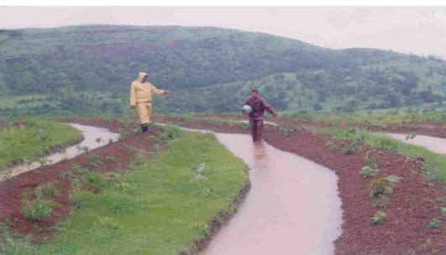
CCT in wet zone –Vitha Bhojdari, Taluka- Akole, Dist.-Ahmednagar
Figure 1 Vitha Bhojdari, Taluka- Akole, Dist.-Ahmednagar

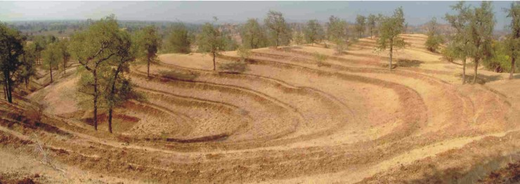
CCT in Barren land – Varad Taluka- Chopada dist. Jalgaon
Figure 2 Varad Taluka- Chopada dist. Jalgaon

Visited by

Ms. Tanuja Ariyananda, Director, LRWHF

