Proposed set up for Rain water harvesting System at SDB bank Horana Branch

July 2022
Location: Horana
Roof area = 1330 ft2 or 123 m2
Daily water demand = 45 persons x 3 flushes x 6 liters ( assuming it is dual flush) = 810 liters
Monthly water demand ( 22 working days) = 17,820 liters

Roof runoff potential
Months | Monthly Rainfall (mm) | Monthly potential rainfall (liters)Roof A | Average Monthly demand ( liters) | Deficit or Surplus ( lites)
JAN | 105 | 10,978 | 17,820 | (6,842)
FEB | 94 | 9,828 | 17,820 | (7,992)
MAR | 116 | 12,128 | 17,820 | (5,692)
APR | 220 | 23,001 | 17,820 | 5,181
MAY | 303 | 31,679 | 17,820 | 13,859
JUN | 299 | 31,260 | 17,820 | 13,440
JUL | 256 | 26,765 | 17,820 | 8,945
AUG | 234 | 24,465 | 17,820 | 6,645
SEP | 264 | 27,601 | 17,820 | 9,781
OCT | 380 | 39,729 | 17,820 | 21,909
NOV | 372 | 38,893 | 17,820 | 21,073
DEC | 220 | 23,001 | 17,820 | 5,181
 | 2,863 | 299,327 | 213,840 | 7,123.89

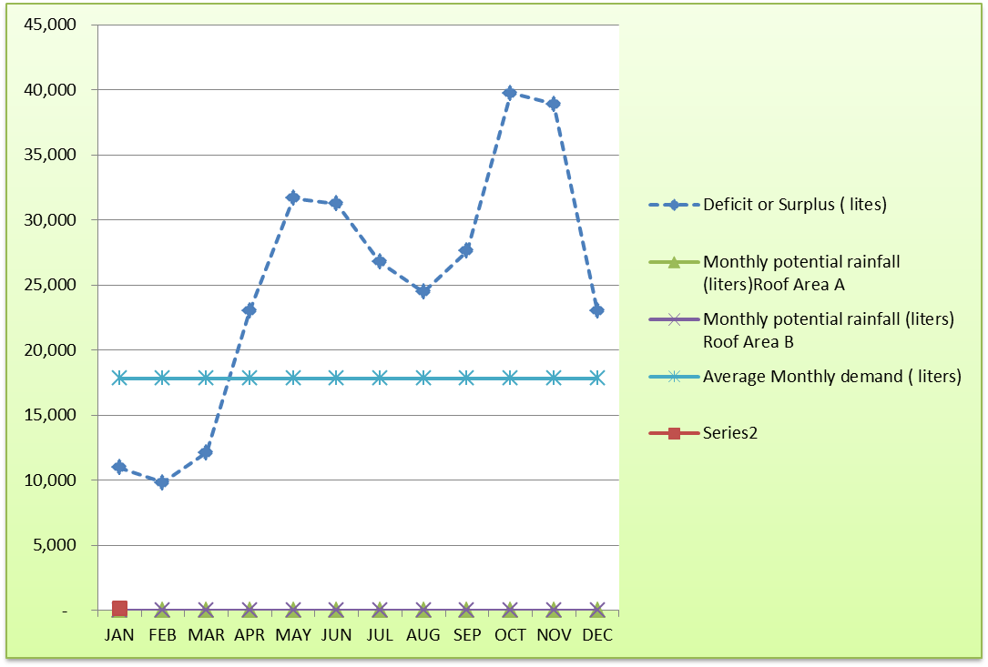

As indicated in the above calculation and graph the storage requirement is over a 3 months period from Jan- March. Ideally 10 m³ or 2 tanks of 5m³ would give around 90 % satisfaction. But if the space is a constraint ( because the diameter of the 5000 liter tank is around 5 ft) it would be better to have 1 tank installed initially and if not adequate have another tank installed. alternatively have 2 tanks of 3 m3 since these tanks are shorter and would be able to fit better inside your building.
The system needs to have a first flush system which allows the first rains to wash the roof. Once we agree on tank capacity etc I will send you details of other components etc.

Design
First flush
Wash out to drain.
Filter basin

Overflow
To distribution line

